THE LOOKING GLASS BEAUTY SCHOOL

Liquid and Powder Acrylic Enhancement CPD Course — Learner Manual
Course author: Jessica Jane Preston
Document review: Version 1.3 — November 2026 | Review by October 2027 or sooner if law, products or guidance change
Continuing Professional Development (CPD) activity — not a regulated qualification.

Document control and permitted use
This manual has been prepared for The Looking Glass Beauty School's Liquid and Powder Acrylic Enhancement CPD Course. It is designed to support qualified beauty or nail professionals in updating and demonstrating safe acrylic enhancement knowledge and practical competence. It does not replace product-specific training, an insurer's requirements, local-authority conditions, a Safety Data Sheet (SDS), or medical advice.

Intellectual property, trademarks and images
Original diagrams and photographs in this pack were created specifically for this course and are owned by The Looking Glass Beauty School. Clinical photographs are reproduced from openly licensed sources under Creative Commons terms; every image is credited beneath its caption and listed in full, with author, licence and source, in the school's image credits and licence register, which is available to learners and assessors on request. Brand names are not used to imply endorsement. Where a tutor identifies a product during a live demonstration, the name is used only so learners can follow that product's instructions. Product labels, logos, screenshots and third-party photographs must not be copied into the course unless the school holds written permission or a suitable licence.
SCOPE BOUNDARY — This course teaches liquid-and-powder acrylic overlays and tip or form extensions on healthy natural fingernails. Gel polish, builder gel and hard gel are compared so learners can recognise the systems and work within scope; this CPD course alone does not qualify a learner to provide those separate services. Electric-file work on the natural nail is not taught or assessed here.

Course author
I am Jessica Jane Preston, a qualified nail professional, beauty educator and salon co-founder with more than fourteen years of industry experience. I hold a VTCT Level 2 NVQ Diploma in Nail Services and an Award in Education and Training. Since 2021 I have delivered classroom-based beauty education and have trained more than 400 learners. My CV and qualification certificates are available from the school on request.

Important professional boundaries
- A nail professional observes, records, adapts, postpones and refers; a nail professional does not diagnose a disease or prescribe medical treatment.
- Never apply uncured product to skin as a 'patch test'. Suspected acrylate allergy requires medical assessment and, where appropriate, formal patch testing by a suitably qualified clinician.
- Do not rely on this manual to override a product label, SDS, manufacturer system guide, local licence condition or insurer instruction.
- Where an urgent reaction includes breathing difficulty, collapse, rapidly increasing facial or throat swelling, or other signs of a medical emergency, call 999. For non-emergency concerns use a pharmacist, GP or NHS 111 as appropriate.

Chapter 1 — Course specification and learning journey
What learners can expect, who the course is for, and how competence is assessed

Course title
Liquid and Powder Acrylic Enhancement CPD Course

Course description
The Liquid and Powder Acrylic Enhancement CPD Course is a practical skills-development activity for existing beauty and nail professionals. Learners revisit nail anatomy and the conditions that require a service to be adapted, postponed or refused; explain the chemistry of monomer and polymer, the mix ratio and free-radical polymerisation; and build a balanced enhancement with a correctly placed apex. Through tutor demonstration and supervised practice, learners prepare the natural nail, fit tips or sculpting forms, apply acrylic in zones with controlled bead consistency, refine the structure, and carry out infills and safe removal. The course also covers dust and vapour control, allergy prevention, equipment care, UK legal responsibilities and honest advertising.
Successful completion requires a theory assessment, a directly observed practical assessment and three satisfactory post-course case studies. This activity is Continuing Professional Development and does not replace or confer a regulated Level 3 nail qualification.
SCOPE BOUNDARY — This course teaches liquid-and-powder acrylic overlays and tip or form extensions on healthy natural fingernails. It does not cover toes, electric-file work on the natural nail, or the correction of significant nail-plate damage or disease.

Entry requirements and prerequisites
- Learners must be aged 18 or over unless the school's insurer has confirmed an alternative minimum age in writing.
- Learners must hold at least a Level 2 Beauty Therapy, Nail Services or equivalent qualification including manicure knowledge, nail structure and safe salon practice. A completed gel-polish or equivalent CPD course alone is not sufficient preparation for an enhancement system.
- Learners must be able to read and follow English-language product labels, Safety Data Sheet information, consultation documents and assessment instructions. Reasonable adjustments will be considered without removing competence or safety requirements.
- Learners must disclose any access, health or allergy needs relevant to safe participation, and must provide a suitable adult model if required by the booking instructions. Learners with a known acrylate sensitivity must not undertake this course.
- Before offering the treatment commercially, learners must confirm that their qualification route, this CPD training and intended working arrangements are accepted by their own insurer and local authority.

Duration and delivery structure
Component | Time | Evidence
Pre-course reading and knowledge activity | 3 hours | Completed learner workbook prompts
Tutor-led classroom and practical day | 7.5 guided learning hours, excluding breaks | Attendance, questioning and direct observation
Three post-course case studies | Approximately 9 hours total | Consultation, treatment record, photographs with consent, reflection and educator feedback
Total learner effort | Approximately 19.5 hours | All evidence retained in the learner portfolio

The lesson plan for the taught day (document A05 in the Tutor and Assessor Pack) sets out the timetable and matches these hours: 7.5 guided learning hours on the day, 3 hours of pre-course reading and about 9 hours of case-study work, 19.5 hours in all. Learners bring a suitable adult model for the afternoon practical and the assessment; the model is confirmed at booking.

Learning outcomes
- LO1 — Explain the purpose, benefits, limitations and client suitability of liquid-and-powder acrylic, and compare it with builder gel, hard gel and gel polish.
- LO2 — Identify the structures of the nail unit and recognise conditions that require an enhancement service to be adapted, postponed or refused.
- LO3 — Conduct and record a professional consultation, obtain informed consent and create an individual treatment plan for an enhancement client.
- LO4 — Explain monomer, polymer, initiator and catalyst, free-radical polymerisation, the mix ratio, set time and the difference between EMA and MMA products.
- LO5 — Select, handle, store and dispose of acrylic products and equipment in accordance with risk assessment, COSHH, manufacturer instructions and current UK requirements.
- LO6 — Control dust and vapour exposure and explain why acrylate overexposure causes sensitisation.
- LO7 — Prepare the natural nail for an enhancement without avoidable damage to the plate or living tissue.
- LO8 — Fit and blend a tip, or fit a sculpting form, achieving a sidewall-to-sidewall fit with no gaps.
- LO9 — Apply acrylic in zones with controlled bead consistency to build a balanced structure with a correctly placed apex, straight sidewalls and an even C-curve.
- LO10 — Refine, finish, infill, repair and safely remove an acrylic enhancement, and provide appropriate aftercare.

Assessment strategy and pass requirements
Theory: a written paper of 38 questions totalling 50 marks, with partial credit for multi-part questions. The pass mark is 80% (40/50). Any answer that instructs a learner to use MMA or an unlabelled product, apply product onto living tissue, work with a wet bead, file without extraction, prise or drill an enhancement off, file the natural nail with an electric file without separate training, or conceal an active infection must be corrected before a pass is awarded.
Practical: direct observation on a suitable adult model, who the learner brings to the taught day. The learner must achieve at least 80% overall (32 of 40 on the marking sheet, document A04) and pass every safety-critical criterion. Cosmetic finish cannot compensate for unsafe preparation, product control, skin contact, dust or vapour control, or removal.
Where the assessment papers are: the theory paper (document A02), its mark scheme (A03) and the practical observation marking sheet (A04) are held in the Tutor and Assessor Pack and are not printed in this manual. The practical is marked on twenty criteria; the seven below are safety-critical and every one must be met for a pass, whatever the overall score:
- No wet product, primer or monomer on skin at any point; a hairline gap kept at the proximal and lateral folds and at the hyponychium.
- A correct mix ratio throughout: no wet beads placed, no bead left to flood the folds, product on skin removed with the brush before it sets.
- Dust and vapour controlled: source-capture extraction on for every filing and removal, the dappen dish lidded between beads, bottles capped, dust damp-wiped.
- No cutting of living tissue; no filing into the lateral folds; the natural nail de-shined with 240 grit or finer, not thinned; no electric file on the natural nail.
- The service refused or adapted where a contraindication is present; suspected infection or reaction never covered; no fresh product applied over lifted product.
- Removal and infill by the methods in Chapter 15: bulk reduced by hand file and product soaked, never prised, nipped, drilled or filed down to the plate.
- Hygiene: single-use items not reused, tools decontaminated between clients, the blood or skin-break procedure followed if needed.
Case studies: three complete acrylic services after the taught day, each with consultation, before and after images where separate consent is held, product record, treatment notes, aftercare and reflection. All three must be satisfactory.
Certification: the CPD certificate is released only after theory, practical and case-study requirements are complete. Attendance alone is not sufficient.

Chapter 2 — Liquid-and-powder acrylic: purpose, benefits and professional scope
Understanding the system before learning the technique

What liquid-and-powder acrylic is
A liquid-and-powder acrylic enhancement is formed by combining a liquid monomer with a polymer powder. The two react chemically and harden without a lamp. The professional draws a bead onto the brush, places it on the nail and shapes it while it is workable; the bead then sets, is refined by filing, and is finished to a high shine or coated with colour.
Because the material sets by chemical reaction rather than by light, there is no cure time to control with a lamp. Instead the professional controls the result through the mix ratio, bead placement and working speed.
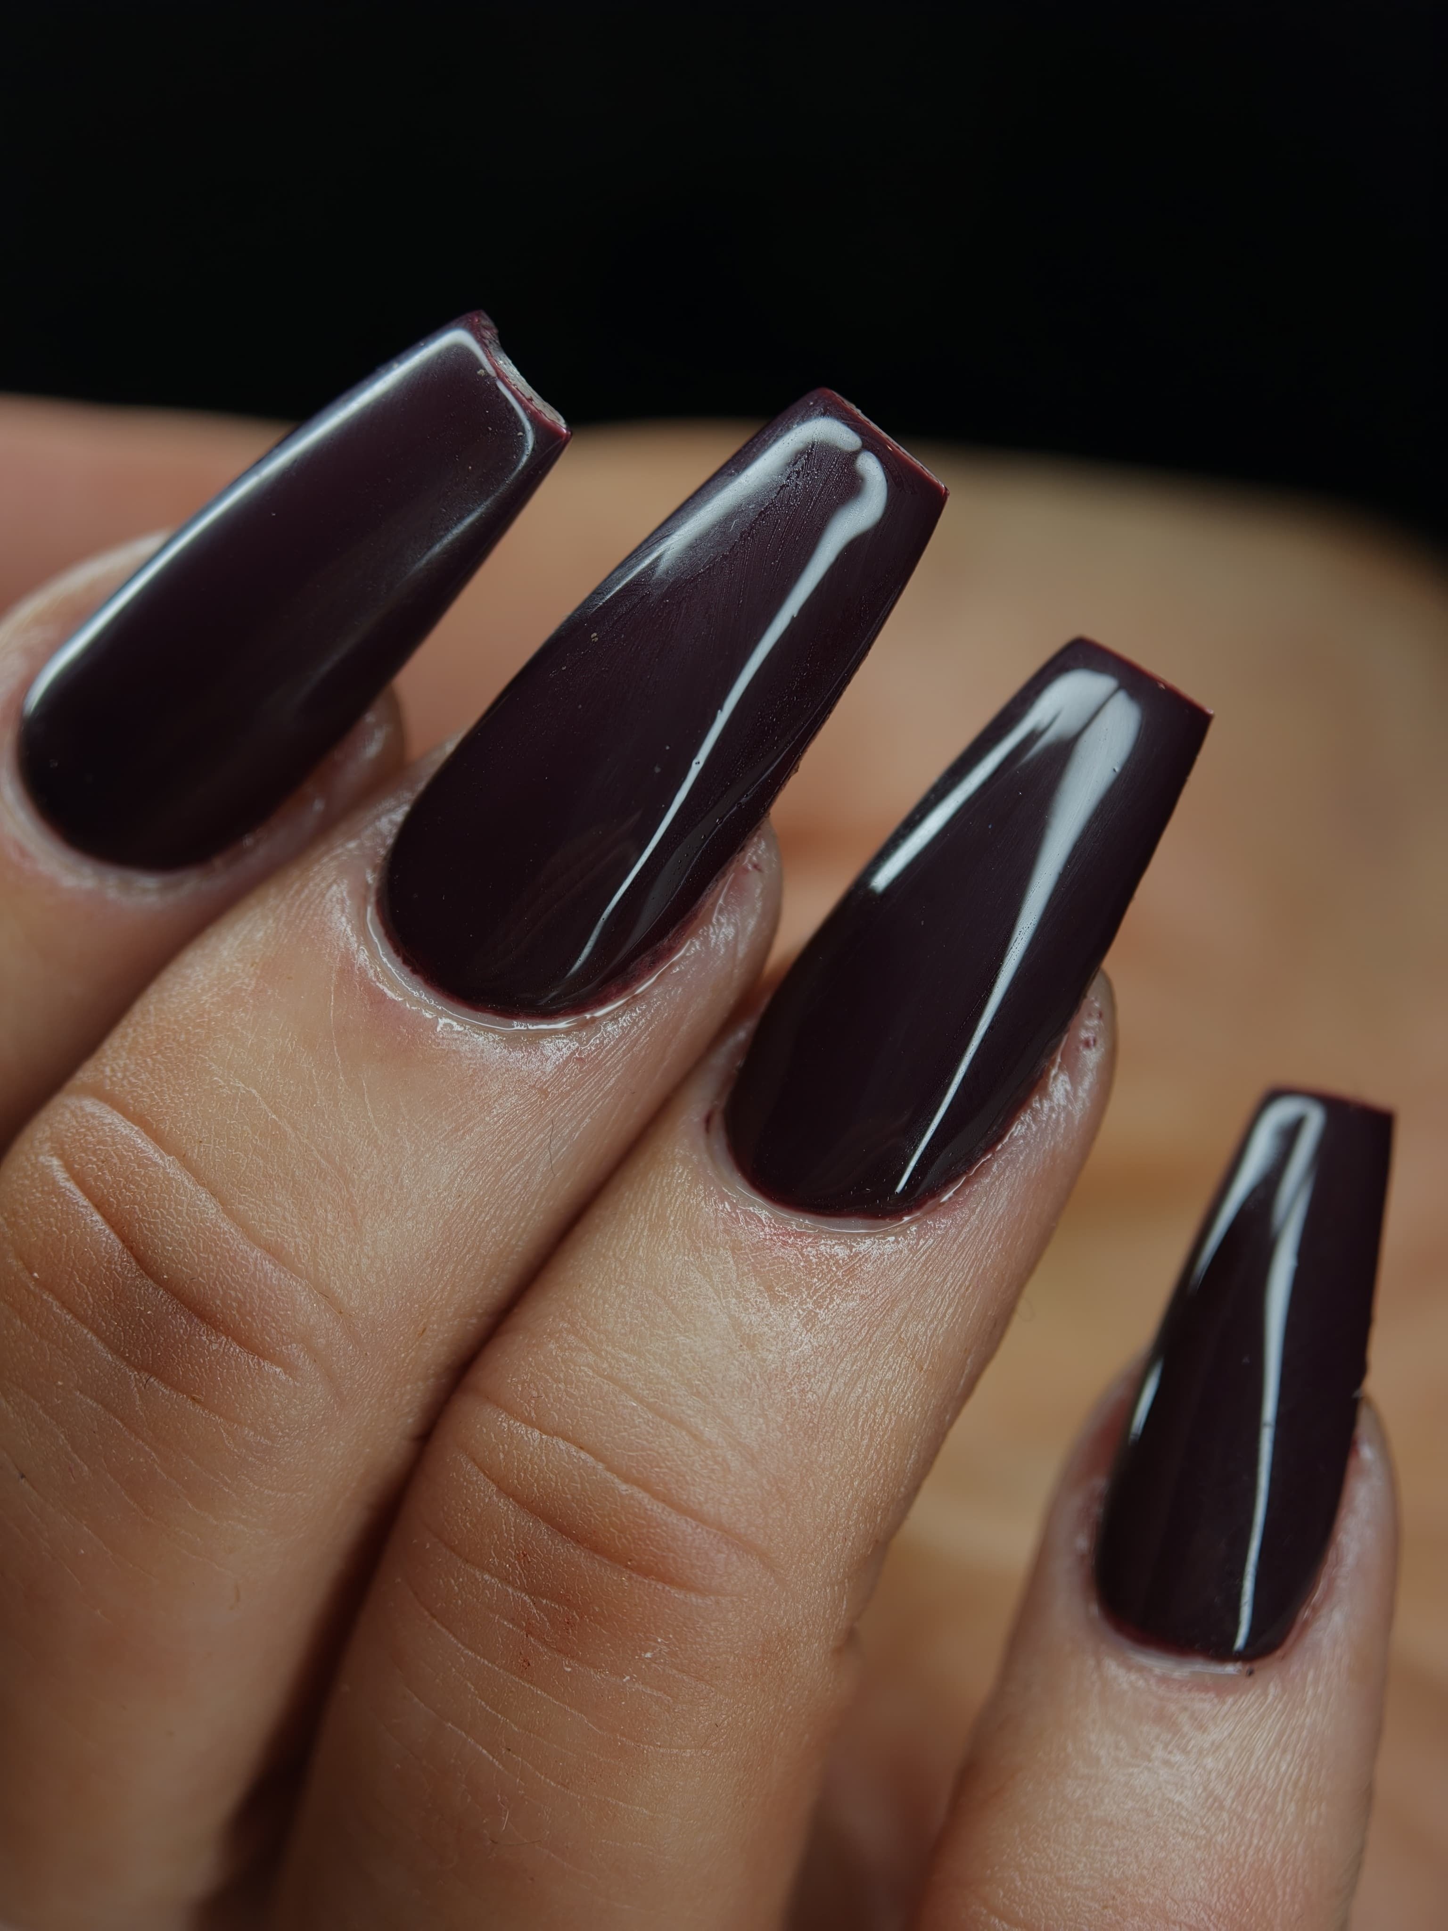
A finished liquid-and-powder acrylic set on sculpted extensions. An even, high-gloss surface, the apex in the back third of each nail, a smooth taper to the free edge, straight parallel sidewalls and a clean hairline gap at every fold. This is the standard the course works towards.
Photograph © The Looking Glass Beauty School, 2026.

Benefits and limitations
Potential benefit | Professional limitation
Strong, durable structure suitable for clients who are hard on their nails | Strength comes from correct architecture, not from thickness. A thick, badly balanced enhancement is weaker than a thin, well-balanced one.
Can add length using tips or sculpting forms | Added length increases leverage on the natural nail. Length must be agreed against the client's work and lifestyle, not simply requested.
Sets without a lamp, so no cure-related under-curing | Set time varies with product, room temperature and ratio. A bead that sets too fast cannot be shaped; too slow and it slumps into the cuticle area.
Colour and design can be embedded within the product | Coloured powders vary in density and may change the working time.
Maintained by infill rather than full removal | Infills must rebalance the structure, not simply fill the regrowth gap. Repeated filling without rebalancing moves the apex and causes breakage.
Removed by soaking off in acetone | Removal is slower than gel polish. Forced prising or nipping removes layers of the natural nail plate and is never acceptable.

Who the treatment may suit
- A client with healthy natural fingernails and intact surrounding skin who wants added strength, length or shape.
- A client who understands that enhancements are a commitment requiring infills every two to three weeks and professional removal.
- A client whose chosen length and shape are practical for their work, caring responsibilities, sport and hobbies.
- A client whose consultation reveals no active contraindication and whose treatment can be completed within the learner's competence, insurer conditions and product instructions.

When another service may be more appropriate
- Gel polish suits a client who wants colour on a healthy natural nail without added structure.
- A builder-gel overlay may suit a client who wants modest reinforcement with a softer feel and a simpler removal, where the professional is separately trained in that system.
- No enhancement should be used to conceal a suspected infection, unexplained nail change or active reaction.
- A client who repeatedly picks or prises product off may damage the natural nail more than the enhancement protects it. Address the behaviour before continuing the service.

Comparing the principal nail systems
System | How it hardens | Removal | Training boundary
Liquid-and-powder acrylic | Chemical reaction between monomer and polymer; no lamp | Soak off in acetone, usually after reducing bulk | Practical focus of this course
Builder gel in a bottle | Light cure in a compatible lamp | Product-specific: soak off, file off or combined | Separate training required
Hard gel | Light cure; rigid or semi-rigid | File off; acetone does not normally remove it | Separate training required
Gel polish | Light cure; thin colour coating with no structure | Soak off as directed | Separate training required
Traditional lacquer | Air dries by solvent evaporation | Lacquer remover | Manicure competence still required

QUICK CHECK — A client asks for long stiletto nails for a job that involves lifting stock. Explain the leverage problem in plain terms, offer a shorter and stronger shape, and record what was agreed. Meeting a request that will break within days is not good service.

Where liquid-and-powder acrylic came from
The first acrylic nail was an accident. In the mid-1950s a Philadelphia dentist, Frederick Slack, repaired a nail he had damaged at work with dental acrylic and a piece of foil; the result held, and with his brother he patented a nail system and the trade in 'porcelain' nails began. Those early liquids were methyl methacrylate (MMA), borrowed straight from dentistry. Through the 1960s and 1970s complaints of allergy, nail-plate damage and loss of sensation in the fingertips mounted, and by the end of the 1970s the United States regulator had acted against MMA nail products and told manufacturers that their use in nail enhancements was inappropriate. The professional industry moved to ethyl methacrylate (EMA), the monomer in every reputable system today. The service in this manual is that EMA system: a more flexible product that bonds to a properly prepared plate without the extreme hardness that made MMA enhancements shatter and take nail plate with them. Light-cured gels arrived in the 1980s as a lower-odour alternative; liquid-and-powder acrylic remains the strongest and most sculptable of the systems and the one most professionals learn for length.

Service time, pricing and promotion
A full set on tips or forms commonly takes two to two and a half hours for a newly trained professional and 75 to 100 minutes with experience; an overlay on the natural nail 60 to 90 minutes; an infill and rebalance 60 to 75 minutes; a removal 45 to 60 minutes including the 20 to 30 minute soak. French, coloured powders or an embedded design add 15 to 30 minutes. Price the service on your time, product cost and your market, not on what a competitor charges. The points below are a starting framework; set your own figures.
- Full set: the highest price on the nail menu, reflecting time, skill and product; sculpted forms are often priced above tips.
- Infill and rebalance: priced as a service in its own right, not a discount; it takes most of the time of a full set and all of the skill.
- Removal: a separate charge, reduced or waived when the client rebooks a new set the same day.
- Repair of a single nail within the first few days: at your discretion, and only once the cause has been looked at.
- French, colour or embedded design: a supplement on top of the set price.
Promotion that works: photograph every set from above, from the side and from the barrel, with consent and in the same light; a side view showing a clean apex and a barrel view showing an even C-curve are the pictures other professionals notice. Describe the service honestly in line with Chapter 10 (strong and long-lasting, never 'guaranteed not to lift' or 'does no damage'). Book the infill at the end of every appointment, two to three weeks ahead: it protects the natural nail and keeps the diary full. Tell clients plainly who acrylic is for and who it is not for; the client who leaves with the right service is the one who comes back.

Chapter 3 — Nail anatomy, physiology and growth
The structures a nail professional must protect
The nail unit is more than the visible plate. It includes living skin, growth tissue, protective folds and supporting structures. Understanding the difference between living and non-living tissue is essential because a cosmetic service should not deliberately cut, abrade or seal over damaged living tissue.
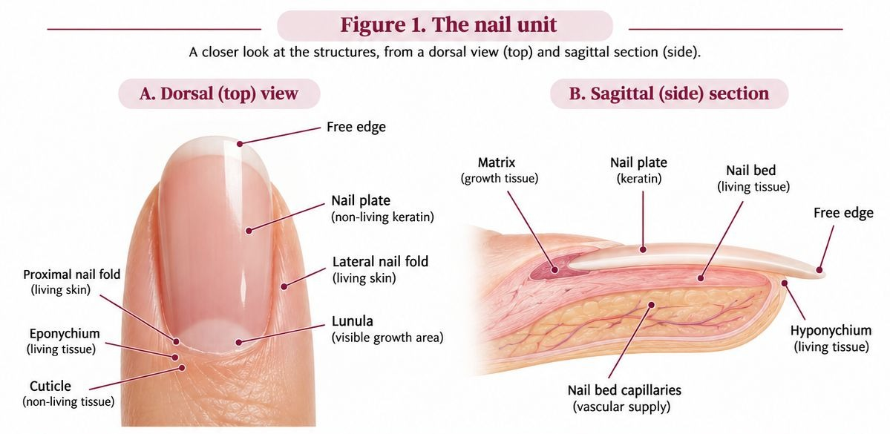
Figure 1. The nail unit. A: dorsal view. B: sagittal section. The matrix produces the nail plate and is continuous with it. The free edge beyond the hyponychium is unsupported.
Original photographs and artwork © The Looking Glass Beauty School, 2026.

Structures and functions
Structure | Function and professional relevance
Matrix | Living growth tissue beneath the proximal nail fold. Matrix cells divide, flatten and keratinise to form most of the nail plate. Significant injury can alter future nail growth; the matrix must never be deliberately filed, cut or probed.
Nail plate | The visible, hard but flexible keratin structure. It contains no blood vessels or nerves. Its layers can be thinned or delaminated by over-filing, peeling product, trauma and repeated dehydration.
Nail bed | Living, vascular tissue beneath the plate that supports and anchors it as it advances. It contributes to the pink appearance of a healthy attached nail. Separation of plate from bed is onycholysis.
Proximal nail fold / proximal nail wall | Living skin at the base of the nail that protects the emerging plate and matrix. It is not 'dead cuticle' and should not be aggressively pushed back or cut.
Lateral nail folds / nail walls | Living skin along each side of the plate. They protect the nail unit and guide the plate. Filing into these folds can cause pain, breaks in the barrier and infection risk.
Cuticle | Thin non-living tissue shed from the underside of the proximal nail fold and carried onto the plate. Only loose or adhered non-living tissue is gently removed during preparation.
Eponychium | Living tissue associated with the proximal nail fold and protective seal. It is often incorrectly called the cuticle. Do not cut it simply to create a visually 'clean' margin.
Lunula | The visible pale crescent of the distal matrix on some nails, most obvious on thumbs. Its visibility varies and absence from view is not automatically abnormal.
Hyponychium | Living tissue beneath the free edge where the nail bed ends. It forms a protective barrier. Do not dig under, cut or separate it while cleaning or shortening the nail.
Free edge | The part of the plate extending beyond the fingertip. It can be shortened and shaped while the finger and sidewalls are supported.
Nail grooves | Channels at the sides in which the plate advances. Product should not be flooded into these areas.
Onychodermal band | The transition between nail bed and hyponychium, sometimes visible as a narrow colour change beneath the plate. It is part of the distal protective seal.

How the nail grows
New nail-plate cells are produced in the matrix. As cells mature they flatten, lose their nuclei, fill with keratin and are pushed distally over the nail bed. A fingernail commonly grows at around 3 mm per month, although the rate varies between people, fingers and seasons. A completely new fingernail may take roughly four to six months to grow from matrix to free edge. Growth may be slower with age, illness, impaired circulation, nutritional deficiency, some medication and significant trauma. Use a range and explain variation rather than promising an exact regrowth date.

Factors that can influence nail appearance and growth
- Local trauma: crushing, repeated tapping, biting, picking, over-filing and forced product removal can affect the plate, bed or matrix.
- Water and chemicals: repeated wetting/drying, detergents and solvents can contribute to brittleness and delamination.
- General health: illness, fever, inflammatory skin disease, anaemia and other conditions may be associated with nail changes, but a nail professional must not diagnose the cause.
- Medication and medical treatment: some medicines and treatments can change growth, colour, thickness or fragility. Record only information relevant to treatment safety and refer when the change is new or unexplained.
- Age and individual variation: ridging, thickness and growth rate vary. A difference is not automatically disease, but a sudden or marked change should not be concealed.
- Product and technique: incorrect preparation, a wet mix ratio, skin contact, thick or badly balanced product, aggressive removal and excessive enhancement length can damage or destabilise the service.

Protecting the natural nail
- Use the least abrasive preparation permitted by the product manufacturer. Do not 'etch' grooves into the plate.
- Support the finger and use light, controlled strokes. Stop if the client reports heat, pain or tenderness.
- Keep wet product, primer and monomer away from all skin and from the underside of the free edge unless the system specifically directs otherwise.
- Never use the enhancement as a tool to prise, scrape or pick. Preventing mechanical trauma is part of aftercare.
- If the nail plate is visibly thin, sore or over-filed, postpone the enhancement and allow recovery rather than hiding the damage.

Chapter 4 — Nail diseases, disorders and recognition
Observe, record, decide and refer — never diagnose
A disease is a pathological process such as infection or inflammatory illness. A disorder or nail change may be traumatic, congenital, behavioural or associated with general health. The categories overlap, and appearance alone is not enough to diagnose. A nail professional should describe what is seen, ask relevant questions, decide whether treatment is safe and refer when uncertain.
FOUR-STEP DECISION — OBSERVE the nail and surrounding skin. ASK when it began, whether it hurts or itches, and whether it is changing. DECIDE whether to proceed, adapt or postpone within your competence and insurance. RECORD the decision and REFER when there is infection, inflammation, unexplained change, pain, broken skin or uncertainty.

Core diseases and disorders
Condition or change | What may be observed | Professional action
Onychomycosis (fungal nail infection) | Thickened, brittle, crumbly or discoloured nail; debris; lifting may occur. Psoriasis and trauma can look similar, so visual inspection is not a diagnosis. | Do not apply or reapply an enhancement. Avoid cross-contamination, use single-use items appropriately and advise the client to seek pharmacist, GP or podiatry advice. Treatment is medical, not a salon service.
Onycholysis | Separation of the nail plate from the bed, often beginning distally. The detached area appears white, grey or discoloured. Causes include trauma, psoriasis, fungal infection, irritants and other conditions. | Do not cover active, extensive, painful, discoloured or unexplained separation. Keep the area dry, avoid probing under the plate and refer. A stable, diagnosed residual change may be treated only with insurer approval and no contraindication.
Onychophagy (nail biting) | Short, irregular free edge; surrounding skin may be picked, sore or broken. Severity varies. | Do not treat over broken, bleeding, inflamed or infected skin. Mild biting with intact skin may allow a short, carefully built overlay or extension once the plate has enough length to hold a tip or form; expectations and maintenance must be realistic, and the client must agree not to bite the product.
Nail psoriasis | Pitting, thickening, colour change, crumbling, onycholysis or oil-drop/salmon patches may occur. It is inflammatory and not contagious. | Do not diagnose. Avoid treatment during an active painful flare, where skin is broken, or where the presentation is uncertain. Stable diagnosed psoriasis may sometimes be treated with medical/insurer guidance and gentle technique.
Paronychia | Red, swollen, warm and tender nail fold; pus may be present. It may be acute bacterial infection or chronic inflammation associated with repeated wet work. | Refuse treatment. Do not drain, cut, massage or cover the area. Advise prompt pharmacy/medical assessment, especially if pain, pus, spreading redness or systemic illness is present.
True pterygium | Scar-like adhesion or abnormal forward growth of tissue involving the nail unit. Dorsal pterygium can split or narrow the plate; pterygium inversum affects tissue beneath the free edge. | Do not confuse true pterygium with ordinary cuticle. Do not cut or push adherent living tissue. Refer for medical assessment before any enhancement.
Onychogryphosis (thick dystrophic nail) | Marked thickening, curvature and distortion of the nail, which may trap debris or be difficult to cut. It usually affects toenails and is often associated with pressure, age or neglect. | An acrylic enhancement is inappropriate. Do not aggressively file or coat. Refer to a podiatrist/medical professional, especially where diabetes, poor circulation, pain or infection risk is present; do not attempt aggressive reduction unless separately qualified and insured.
Brittle or splitting nails (onychoschizia/onychorrhexis) | Peeling layers, transverse splitting or longitudinal ridges/splits. Repeated water/chemical exposure and trauma can contribute; systemic causes are also possible. | Mild stable brittleness with intact skin may receive a carefully built, short enhancement if suitable. New, severe, painful or multiple-nail changes require referral. Do not promise that an enhancement will cure the cause.
Koilonychia (spoon nails) | A concave or spoon-shaped plate. It can be congenital, traumatic or associated with health conditions such as iron deficiency. | If new or unexplained, refer. Do not use product to disguise a possible health sign. If longstanding, medically reviewed and intact, treatment may be adapted within insurer conditions.
Duckbill / flared nail shape | The free edge widens or fans outward. This may be the natural growth pattern or result from previous enhancement architecture. | Not automatically a disease. Keep length practical, refine only without weakening sidewalls, and choose a flattering shape. A well-placed apex and a form fitted to the natural C-curve can improve the look; do not pinch the sidewalls to correct it.
Leukonychia (white spots) | Small opaque white marks commonly follow minor matrix trauma and grow out with the plate. Widespread, powdery or changing white areas can have other causes. | A few stable trauma-related spots on an otherwise healthy nail can usually be coated. Do not diagnose. Refer powdery, spreading, lifting, painful or unexplained changes.
Beau's lines | Transverse depressions caused by temporary interruption of nail growth. They may follow illness, injury or other stress. | If shallow, growing out and the nail is healthy, a gentle cosmetic service may be possible. New, deep, multiple or unexplained lines should be referred.
Splinter haemorrhage | Fine red-brown or black lines beneath the plate, often from minor trauma but sometimes associated with health conditions. | If clearly linked to minor trauma and growing out, record and monitor. Multiple, recurrent or unexplained marks require medical advice. Never cover a suspicious dark streak without referral.
Subungual melanoma warning sign | A new or changing dark longitudinal band, pigment spreading onto surrounding skin, nail destruction, bleeding or a persistent unexplained lesion. | Do not cover. Urgently advise GP assessment. Nail melanoma is uncommon, but delay caused by cosmetic concealment is unacceptable.

Recognising what you are looking at
The photographs below show presentations you may meet at the consultation. Use them to recognise and describe what you see — never to diagnose. Where a nail does not look like any of these, that is itself a reason to pause and refer.
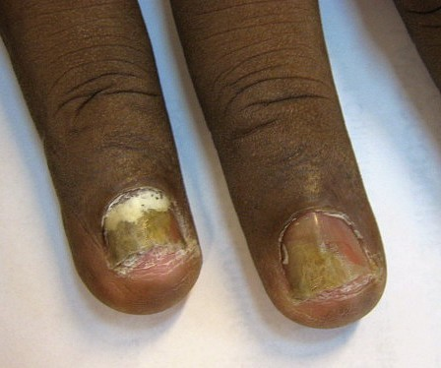
Figure 2. Onychomycosis affecting two fingernails. Yellow-brown discolouration, thickening, crumbling of the plate and separation at the free edge. Do not apply or reapply an enhancement — treatment is medical, not a salon service.
Photograph © Grook Da Oger, via Wikimedia Commons, CC BY-SA 3.0.
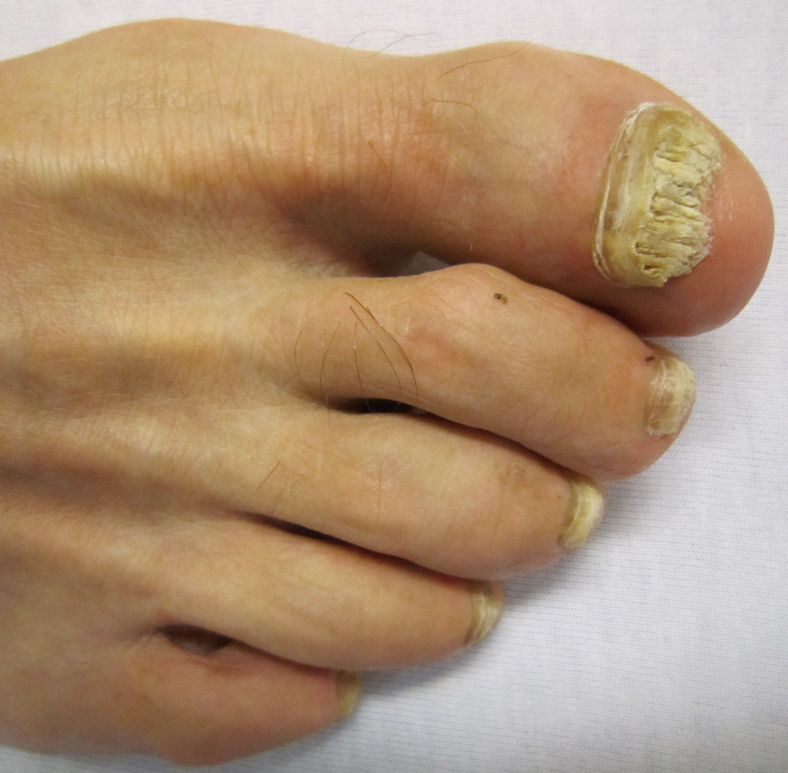
Figure 3. Onychomycosis more commonly affects toenails, as here: marked thickening, yellow-white crumbling and debris beneath the plate. Psoriasis and repeated trauma can look similar — visual inspection is never a diagnosis.
Photograph © James Heilman, MD, via Wikimedia Commons, CC BY-SA 3.0.
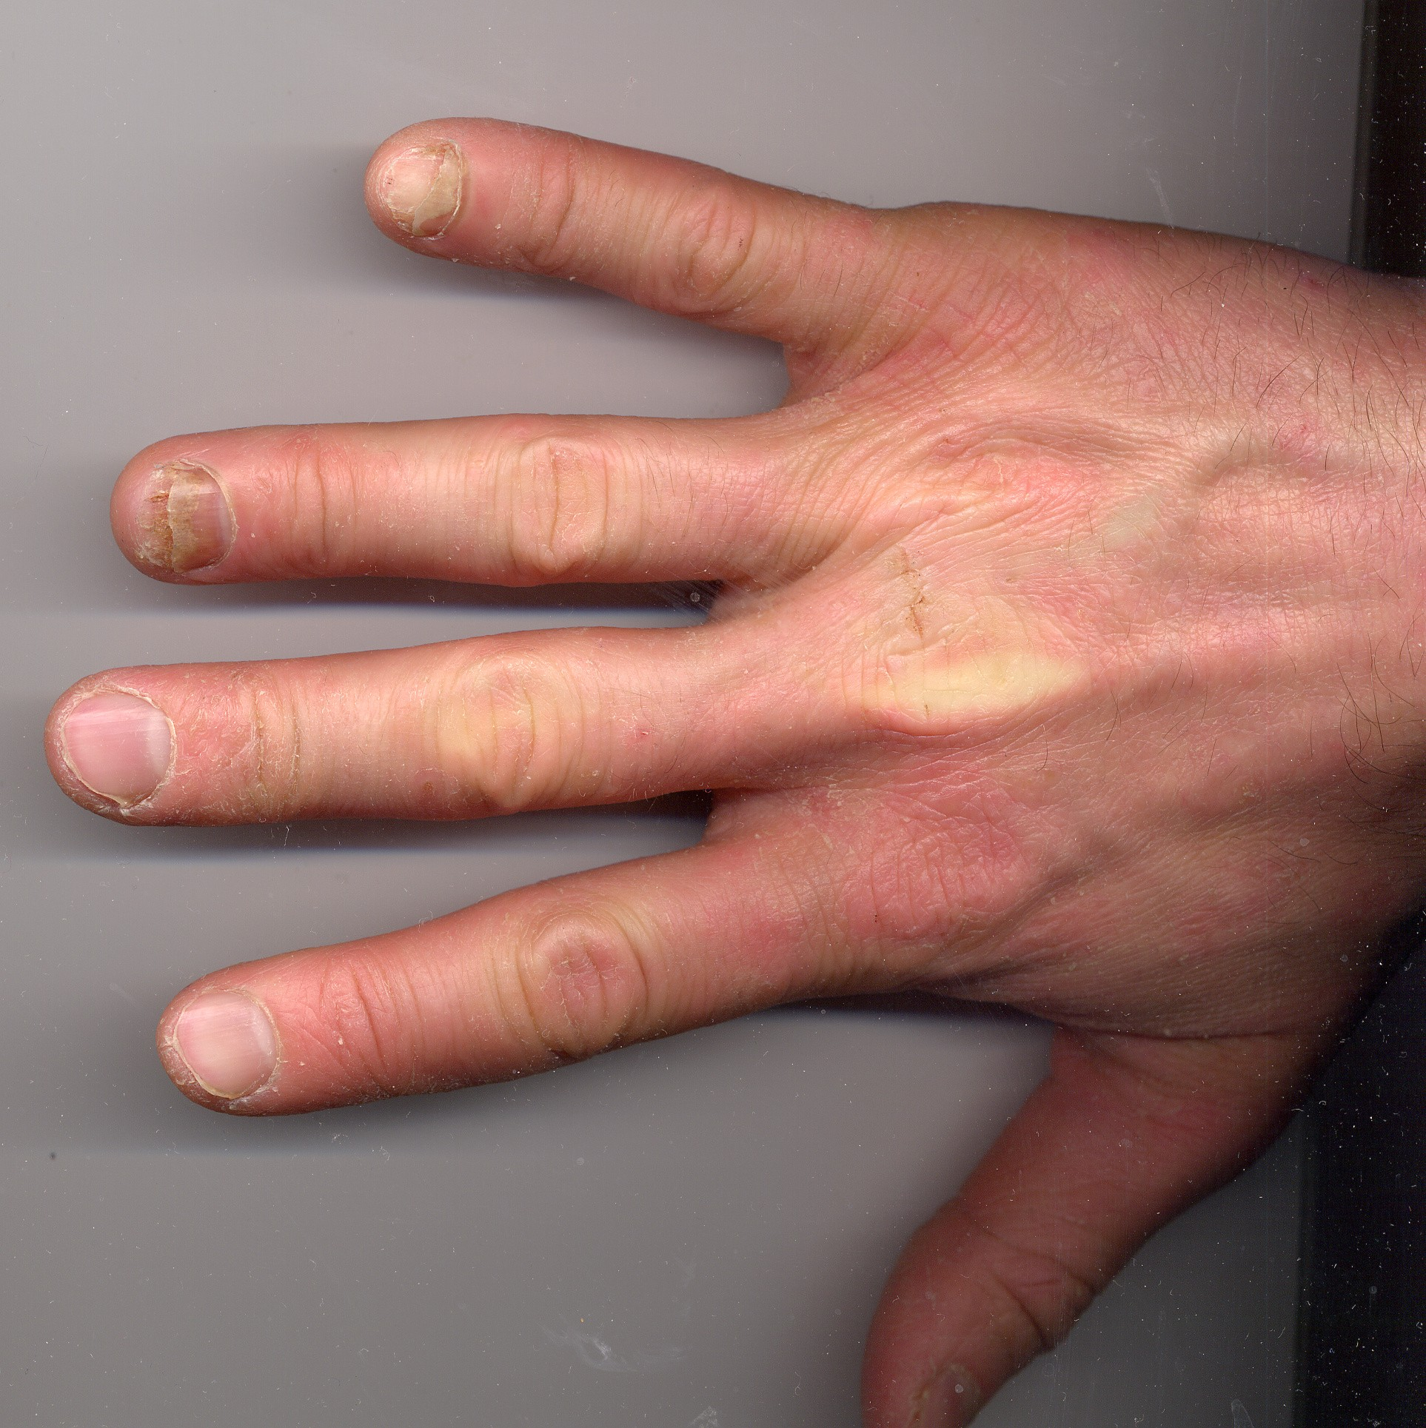
Figure 4. Onycholysis of the ring and little fingernails. The plate has separated from the bed beginning at the free edge, and the detached area appears pale and discoloured. Do not cover active, extensive or unexplained separation.
Photograph © CopperKettle, via Wikimedia Commons, CC BY-SA 3.0.
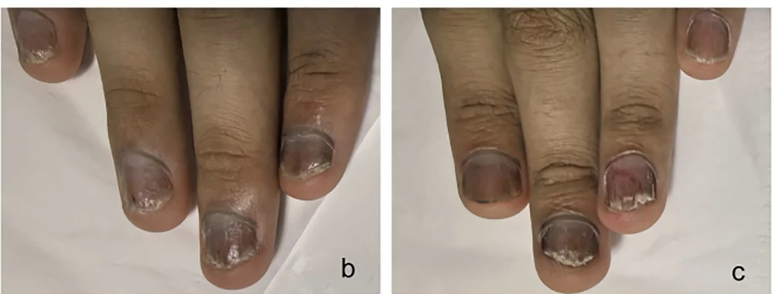
Figure 5. Nail psoriasis. Crumbling of the plate, subungual debris, colour change and separation at the free edge. Psoriasis is inflammatory and not contagious, but it can look very like fungal infection — which is exactly why appearance alone is never a diagnosis. Avoid treatment during an active flare, where skin is broken, or where the presentation is uncertain.
Photograph © Huang Y & Wen S, Frontiers in Immunology (2026), doi:10.3389/fimmu.2026.1941127, CC BY 4.0, cropped. Paediatric patient.
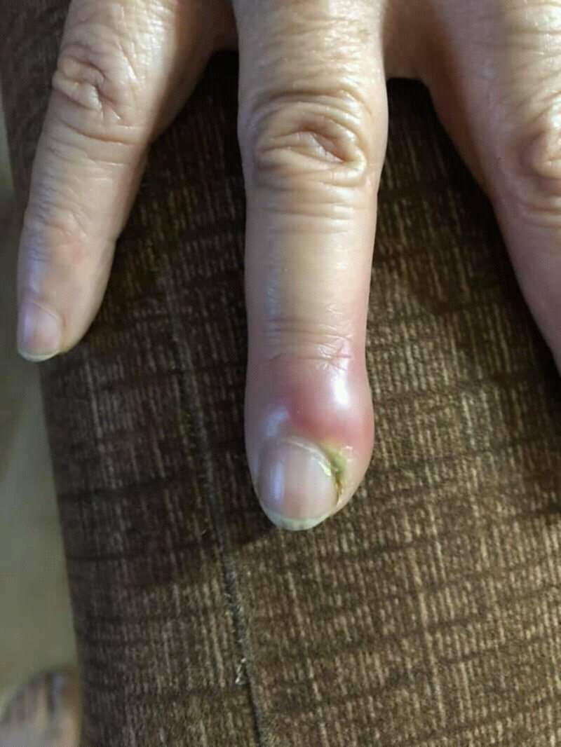
Figure 6. Acute paronychia. The nail fold is swollen, red and tender, with pus present. Refuse treatment. Do not drain, cut, massage or cover the area; advise prompt pharmacy or medical assessment.
Photograph © Mohammad2018, via Wikimedia Commons, CC BY-SA 4.0.
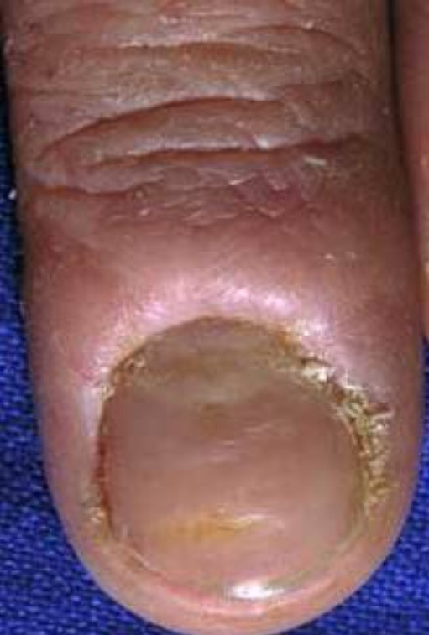
Figure 7. Chronic paronychia. The cuticle seal is lost, the proximal nail fold is thickened and bolstered, and the plate shows ridging and colour change. Commonly associated with repeated wet work.
Photograph © Daifallah M. Al Aboud, M.D., via Wikimedia Commons, CC BY 4.0.
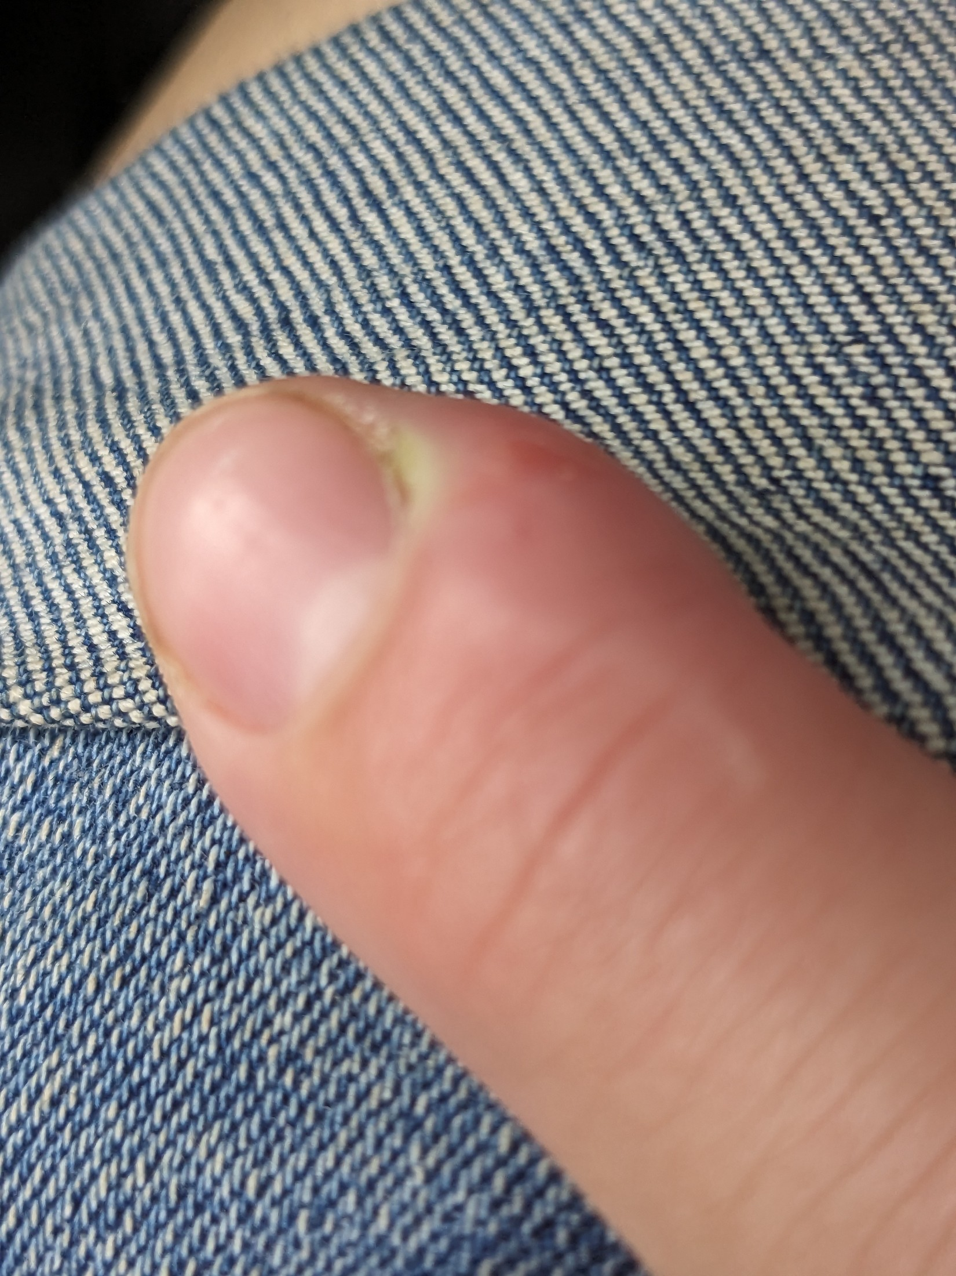
Figure 8. Early paronychia. Localised swelling and a small pus point at the nail fold, with the skin barrier already broken. Even at this stage the service is refused and the client referred.
Photograph © Hannah Clover, via Wikimedia Commons, CC BY 4.0.
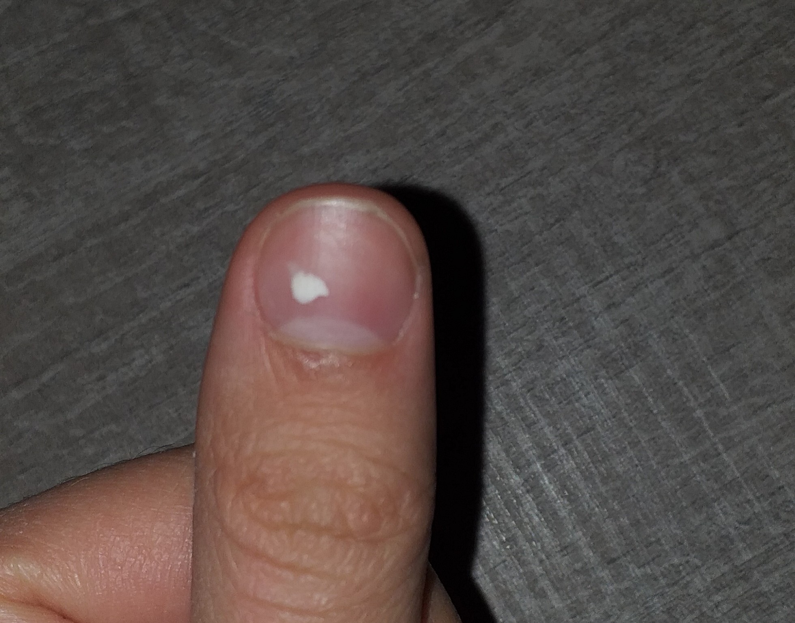
Figure 9. Leukonychia punctata. A single opaque white spot following minor matrix trauma, which grows out with the plate. A few stable spots on an otherwise healthy nail can usually be coated — but do not diagnose.
Photograph © BrotherLongLegs, via Wikimedia Commons, CC BY-SA 4.0.
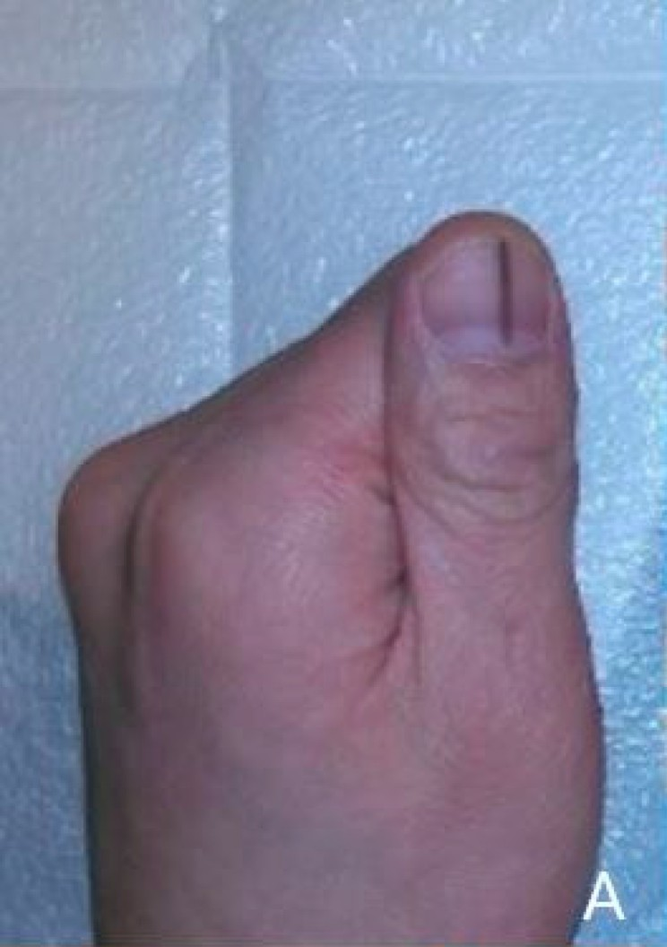
Figure 10. Longitudinal melanonychia — a dark band running the length of the plate. DO NOT COVER. A new or changing band, pigment spreading onto the surrounding skin, nail destruction or bleeding requires urgent GP assessment.
Photograph © Seungjun Lee & Seokchan Eun, via Wikimedia Commons, CC BY 4.0.

Green nail and suspected bacterial infection
Green, green-black or yellow-green discolouration beneath a lifted enhancement is commonly associated with colonisation by Pseudomonas bacteria in a moist space, although colour alone cannot confirm the organism. It is not correctly described as 'green fungus'. The professional response is not to hide the stain or prescribe a home chemical remedy.
- Stop the service and do not apply fresh product over the discolouration.
- If an existing enhancement can be removed without cutting skin or over-filing, remove it using the correct product method and within competence. If safe removal is uncertain, refer to a suitably qualified professional.
- Keep the nail clean and dry. Do not dig under separated plate, buff away colour or use household bleach, neat vinegar, antibiotics or another treatment unless directed by a healthcare professional.
- Advise the client to seek medical or pharmacy advice, particularly where there is pain, swelling, pus, spreading redness, diabetes, reduced immunity or persistent discolouration.
- Discard contaminated single-use items, quarantine reusable tools and complete the full cleaning/disinfection or validated sterilisation process required by the risk assessment. Record the product, affected nails, observations, action and referral.
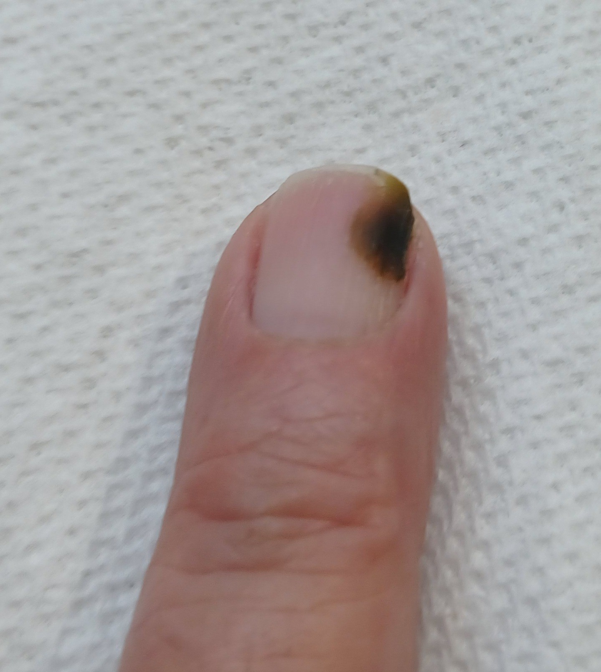
Figure 11. Green nail (chloronychia). Green-black discolouration associated with bacterial colonisation in a moist space. It is not 'green fungus'. Do not apply fresh product over the discolouration.
Photograph by Ekem, via Wikimedia Commons, CC0 1.0 (public domain dedication).
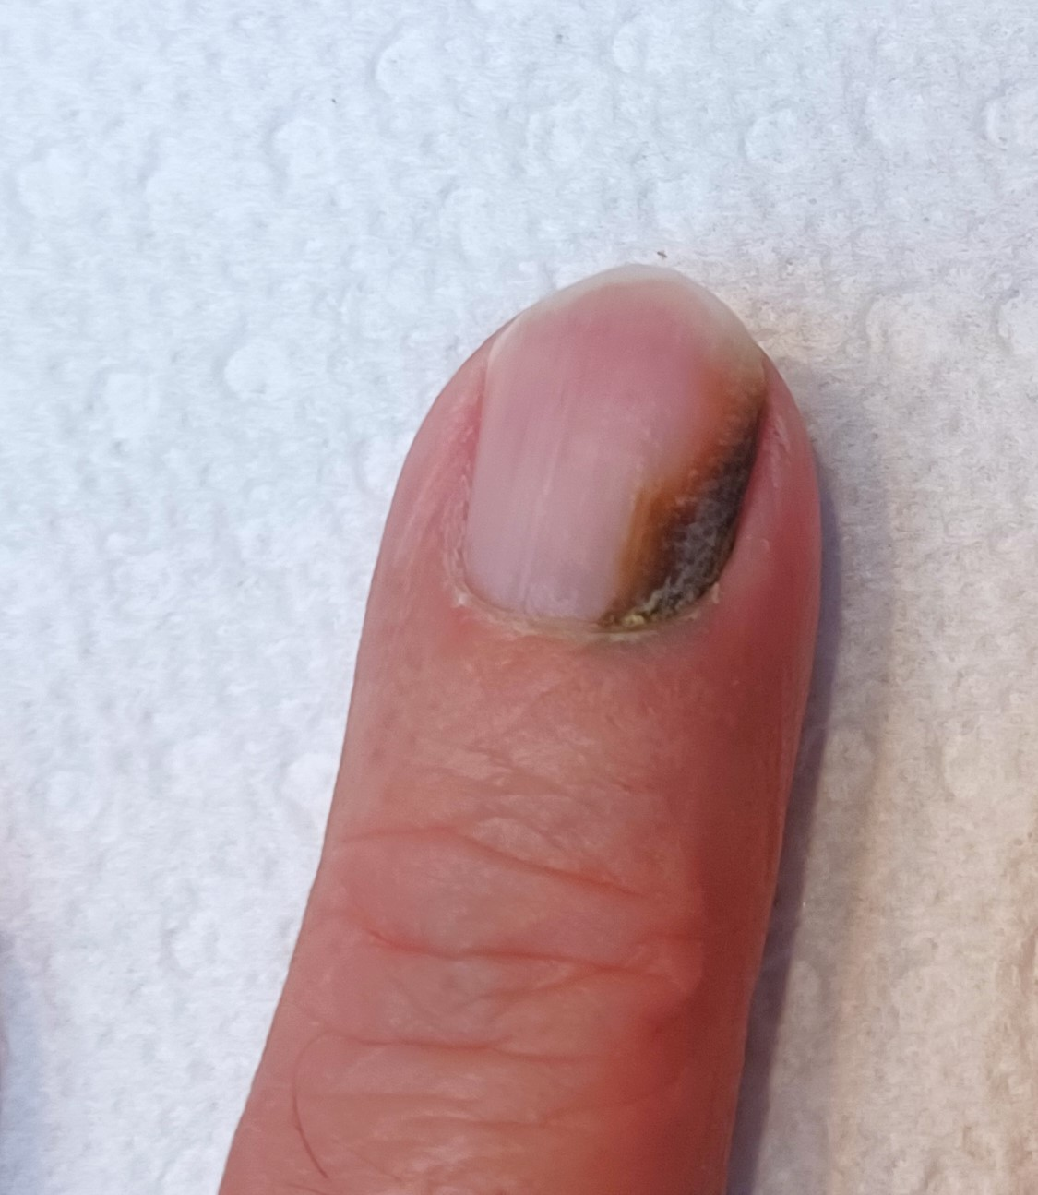
Figure 12. Green nail with associated onycholysis. The discolouration sits beneath a separated area of plate. Do not buff away the colour or use household remedies; keep dry, refer, and decontaminate tools.
Photograph by Ekem, via Wikimedia Commons, CC0 1.0 (public domain dedication).

Contraindications that are not diagnoses
The following findings or circumstances can prevent or restrict an acrylic enhancement service even when no named nail disease has been diagnosed:
- Known or suspected acrylate/methacrylate allergy, or a previous reaction to gel, acrylic, nail glue or adhesive products.
- Active eczema, dermatitis, psoriasis flare or unexplained rash on the hands, fingers or treatment area.
- Cuts, abrasions, bleeding, burns, blisters, swelling, heat, tenderness or recent trauma around the nail.
- A wart or other contagious lesion where the service could touch or spread it.
- Recent surgery, severe nail damage, significant plate thinning or pain on light pressure.
- A new, changing, unexplained or suspicious colour/shape change.
- A client unable to sit still for the length of the service, keep the hands on the desk, follow aftercare, communicate discomfort or give informed consent.
- Any medical condition, treatment or medication for which the insurer or manufacturer requires medical advice, adaptation or refusal. Diabetes and pregnancy are not automatic universal bans; assess individually, avoid injury and follow insurer/product guidance.
DO NOT USE GP LETTERS AS A BLANKET TRANSFER OF RESPONSIBILITY — A doctor's note does not make an unsuitable treatment safe and does not override the professional's competence, product instructions or insurance. Ask only for relevant confirmation, make your own treatment decision and record the rationale.

Chapter 5 — Consultation, treatment planning and consent
A safe service begins before the product is opened

Purpose of the consultation
A consultation is a structured two-way conversation and assessment. It establishes what the client wants, whether the treatment is appropriate, how it should be adapted and whether the client understands costs, maintenance, limitations and risks. A signed form supports the process but is not a substitute for observation, professional judgement or dialogue.

The consultation sequence
- Create privacy and explain why relevant questions are being asked. Confirm the client's identity, age and preferred communication needs.
- Clarify the desired result: colour, finish, shape, length, event, workplace requirements, budget and expected maintenance.
- Ask about previous nail services, wear, lifting, removal methods, reactions, allergies and whether any nails are painful or changing.
- Collect only health and medication information that is relevant to treatment safety. Explain that health data is sensitive and how it will be protected.
- Visually and manually assess the nail plate, free edge, folds, surrounding skin and each hand. Compare nails; do not conceal suspicious findings.
- Identify contraindications and decide to proceed, adapt, postpone or refuse. Explain the reason respectfully without diagnosing.
- Agree a realistic treatment plan: product system, overlay or extension on a tip or form, length, shape, colour or finish, service time, price, infill interval, removal and aftercare.
- Explain foreseeable risks including temporary dryness, a warm sensation as product sets, lifting, breakage, allergy/sensitisation risk and harm from picking or forced removal.
- Obtain treatment consent. Obtain separate, optional consent for identifiable photographs or marketing; refusal of marketing consent must not prevent treatment.
- Record products, batch numbers where practical, tip or form used, length and shape, observations, adaptations and aftercare. Update the record at every appointment.

Treatment planning
A treatment plan converts consultation findings into a safe, individual service. It should be specific enough that another competent professional can understand what was agreed and what happened.
Planning area | What to decide and record
Client goal | Overlay or extension, length, shape, colour or finish, occasion, desired wear and the maintenance commitment
Nail condition | Plate thickness, flexibility, free-edge condition, skin integrity, relevant variations and contraindication decision
Lifestyle | Work, handwashing/wet work, chemicals, sport, gardening, caring, musical instruments, habitual picking and time available for maintenance
System | Named monomer, powder, primer and dehydrator from one system; tips or forms; the Safety Data Sheets held
Adaptation | Shorter length, overlay instead of extension, reduced abrasion, one nail excluded, additional removal time, no cuticle nipping, or treatment postponed
Service variation | New full set on tips or forms, overlay on the natural nail, infill and rebalance, repair, removal, or removal and a new set
Risk and consent | Benefits, limitations, allergy information, aftercare, cost and separate photo consent
Review | Expected maintenance/removal date, what the client should report, and outcome at the next visit

Consent is informed and ongoing
- The client must understand what will be done, material risks, alternatives and the right to stop. A signature does not remove the duty of care.
- Check consent again if the plan changes, discomfort occurs or another product is proposed.
- Do not use coercive wording such as 'I accept all responsibility'. A professional remains responsible for acting competently.
- For case-study photographs, obtain model consent for the educational purpose and specify who will see the images, how long they will be kept and whether the face/identity will be excluded.
- If consent cannot be freely and clearly given, do not treat.

Consultation scenario
LEARNER ACTIVITY — A client asks for long almond nails for a warehouse job, reports that previous acrylics 'always lift', and has a sore split beside the index nail. Identify the immediate contraindication, the lifestyle issue, the questions you would ask and a realistic alternative plan. Record your answer before discussing it with the group.

Chapter 6 — Acrylic chemistry, the mix ratio and set time
Why product control protects the client and the professional

Monomer, polymer and what happens when they meet
A monomer is a small reactive molecule. A polymer is a long chain formed when many monomers join together. The liquid in an acrylic system is largely monomer; the powder is largely pre-formed polymer beads, with an initiator built into them.
When the brush carries liquid into the powder, the monomer begins to dissolve the surface of the polymer beads and releases the initiator. A catalyst in the liquid speeds the reaction. Monomer molecules join into chains around and between the existing beads, and the mixture changes from a workable bead into a solid mass. This is free-radical polymerisation.
The reaction gives off a small amount of heat. On a healthy nail with correct product control this is not usually noticed; if a client reports heat, stop, lift the hand away and check the ratio and the thickness being applied.
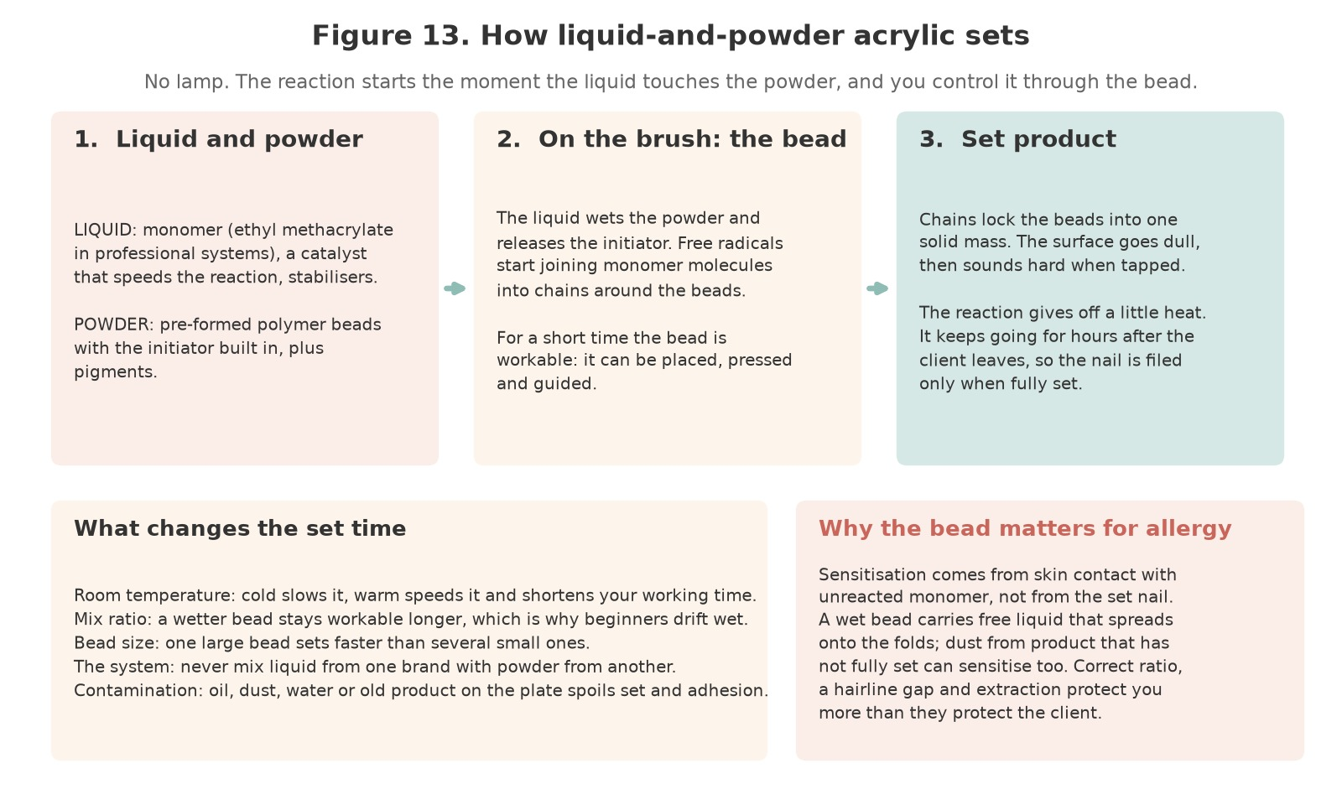
Figure 13. How liquid-and-powder acrylic sets. The liquid wets the powder and releases the initiator; chains form around the polymer beads and the workable bead becomes a solid mass without a lamp. Temperature, ratio, bead size and contamination change the set time; free monomer in a wet bead is the route to sensitisation.
Original illustration © The Looking Glass Beauty School, 2026.

The mix ratio is the main control you have
The mix ratio is the balance of liquid to powder in the bead. It is judged by eye and by how the bead behaves, not measured. Learning to read a bead is the single most important practical skill in this course.
Bead | How it looks and behaves | What it does to the service
Too wet | Runs, spreads on its own, floods the cuticle area and sidewalls, stays shiny and soft for a long time | Weak, porous structure. Uncured monomer sits against skin — the main route to allergy. Service breakdown and lifting.
Correct | Holds its shape, settles gently when pressed, has a soft sheen and can be guided into place before it sets | Even, strong structure with good adhesion and predictable set time.
Too dry | Crumbly, dull, drags on the nail, will not smooth out, shows white specks or crystallisation | Poor adhesion, porous and brittle product, visible surface defects, lifting at the edges.

THE RATIO RULE — Wet beads are the most common cause of both allergy and lifting. If in doubt, wipe the brush on the lip of the dappen dish before picking up powder.
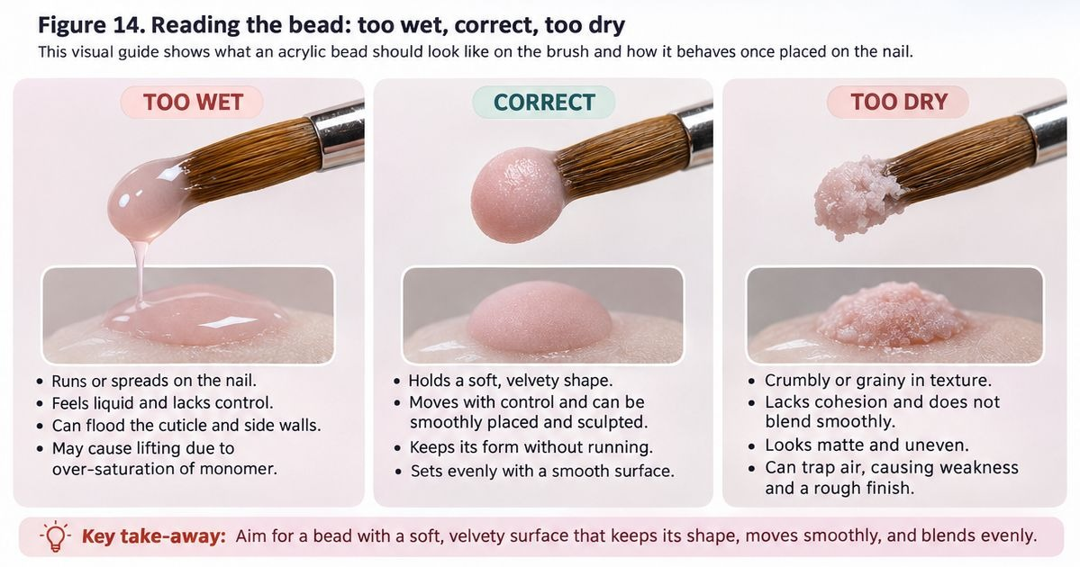
Figure 14. Reading the bead. Too wet runs and floods the folds; correct holds a soft dome and can be guided; too dry is crumbly and will not smooth. If in doubt, wipe the brush on the lip of the dappen dish before picking up powder.
Original photographs and artwork © The Looking Glass Beauty School, 2026.

Set time and what changes it
- Product chemistry: different systems are formulated to set at different speeds. Never mix liquid from one brand with powder from another.
- Room temperature: a cold room slows the set; a warm room speeds it and shortens your working time.
- Mix ratio: a wetter bead takes longer to set and stays workable, which is why beginners drift towards wet beads and build weak nails.
- Bead size: a large bead has more material reacting and sets faster than several small ones.
- Contamination: oil, dust, water or product residue on the plate interferes with both set and adhesion.

EMA and MMA — what a professional must know
The monomer used in professional systems is normally ethyl methacrylate (EMA). Methyl methacrylate (MMA) is a smaller, harder molecule that has been associated with severe natural nail damage, nail-plate separation and allergic reaction when used as a nail monomer.
The accurate legal position in Great Britain is this: methyl methacrylate is not listed as a prohibited substance in Annex II of the retained Cosmetic Products Regulation. However, every cosmetic product placed on the market must be safe for its intended use, and MMA nail liquid is widely regarded across the professional sector as unsuitable for application to the nail. It is prohibited for nail use in many jurisdictions outside the UK. Do not repeat the common claim that MMA is 'illegal in the UK'; explain the safety position instead.
Warning sign of an MMA-type product | What a professional should do
A strong, unusual or fruity chemical smell quite unlike your usual monomer | Stop using it. Obtain the Safety Data Sheet and check the monomer named.
Product that will not soak off in acetone in a reasonable time | Treat as a strong indicator. Do not attempt to drill it off the natural nail.
Enhancement so hard that it shatters rather than flexes, taking nail plate with it | Record the damage, remove as gently as possible and refer if the plate is compromised.
Product sold unusually cheaply, unlabelled, or without a Safety Data Sheet | Do not buy or use it. A supplier who cannot provide an SDS cannot support your COSHH duties.

YOUR SYSTEM — Record the exact monomer and powder you are trained on, and keep the Safety Data Sheet for each. Under COSHH you must base your assessment on the actual product, not on acrylic in general.

Why acrylate allergy happens
Sensitisation is caused by repeated skin contact with uncured product, not by the finished enhancement. Once a person becomes sensitised the reaction is usually permanent, and it can end a career as well as affecting dental and medical treatment later in life. Both the client and the professional are at risk; the professional is exposed far more often.
- Keep uncured product off the skin at all times — the client's and your own.
- Do not touch product with bare fingers to shape it.
- Work with a correct ratio; wet product spreads onto skin.
- Change gloves and wipe down; do not let the brush handle become coated in product.
- Control dust — filings of not-fully-reacted product can also sensitise.
- Never use a product as a 'patch test' on skin.

Chapter 7 — Nail architecture: apex, stress area, C-curve and balance
The part of the job that decides whether the nail lasts
Strength in an enhancement comes from its shape, not its thickness. A correctly shaped nail distributes force through the structure; a badly shaped one concentrates force at a single point and breaks there, however much product has been used.
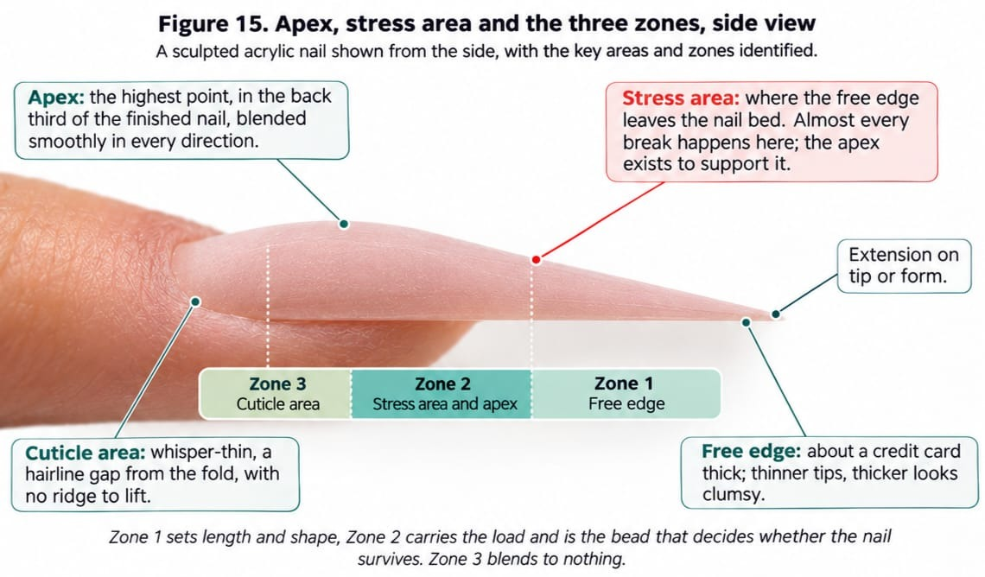
Figure 15. Apex, stress area and the three zones, side view. The apex sits in the back third of the finished nail and supports the stress area where the free edge leaves the bed; zone 3 is whisper-thin with a hairline gap, and the free edge is about a credit card thick.
Original photographs and artwork © The Looking Glass Beauty School, 2026.

The four things a balanced nail needs
Feature | What good looks like | What goes wrong without it
Apex | The highest point of the enhancement, placed in the back third of the nail and blended smoothly in every direction | Apex too far forward: the nail snaps at the stress area. Apex too flat: the nail flexes and cracks. Apex too high: it looks bulbous and catches.
Stress area | The zone where the free edge leaves the nail bed, supported by the apex behind it | Unsupported stress area is where almost all breaks occur.
C-curve | An even transverse curve, consistent from sidewall to sidewall along the length | A flat or uneven C-curve makes the nail weak and the sidewalls look pinched or splayed.
Sidewalls | Straight when viewed from above, meeting the natural sidewall without a step or gap | Product over the sidewall causes lifting and skin irritation; a gap traps moisture and debris.

Thickness
Thickness should be greatest at the apex and taper in every direction. At the cuticle area the product must be whisper-thin so there is no ridge to lift. At the free edge, a useful reference is the thickness of a credit card; thinner and it will chip, thicker and it looks and feels clumsy.

Working in zones
Most educators teach acrylic application in three zones. The zones are a way of controlling where product goes and how much, not a rigid rule about bead count.
Zone | Where | What it does
Zone 1 | The free edge or the extension beyond the natural nail | Establishes length and shape. Usually placed first when working on a form.
Zone 2 | The stress area and the centre of the nail | Builds the apex and carries the structural load. The most important bead on the nail.
Zone 3 | The cuticle area | Blends the structure to nothing. Thin, neat and never touching living tissue.

CHECK FROM EVERY ANGLE — Look down the barrel of the nail from the free edge to see the C-curve, from the side to see the apex, and from above to see the sidewalls. A nail that looks right from only one angle is not balanced.
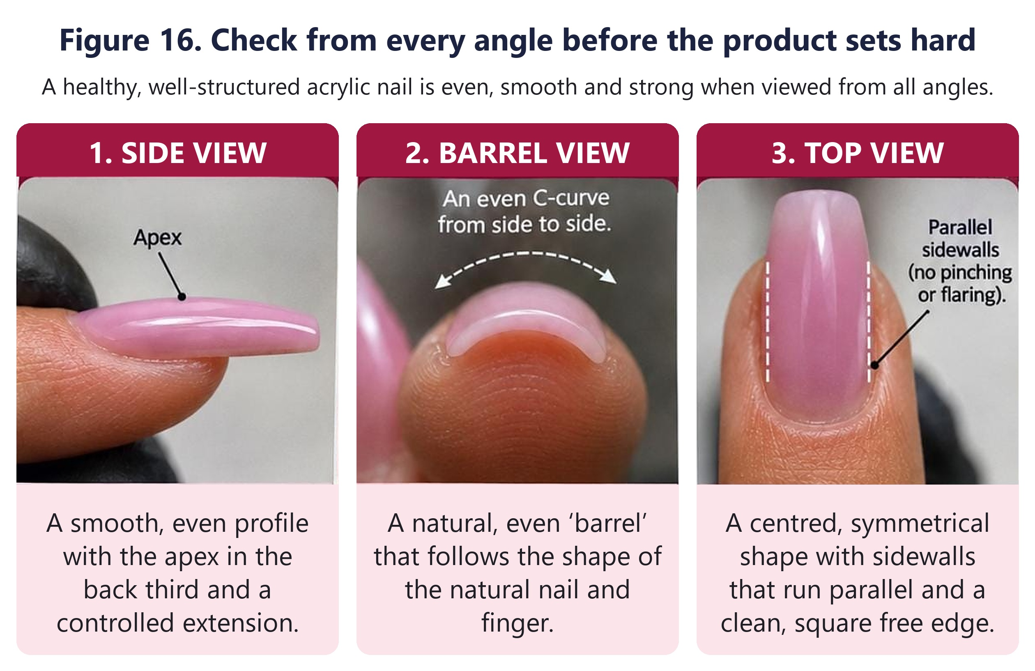
Figure 16. Check from every angle while the product can still be guided: top view for the sidewalls, side view for the apex, barrel view for the C-curve.
Original photographs and artwork © The Looking Glass Beauty School, 2026.
What Figure 16 shows. The three photographs are one finished nail seen from the three positions you check before the product sets hard, because each view shows a fault the other two hide. From the side, the upper surface should rise smoothly from a thin margin at the cuticle area to its highest point, the apex, in the back third of the nail over the stress area, then fall away in one unbroken line to a slim free edge. A flat profile means the stress area has no support and the nail will break there; a hump too far forward makes the nail top-heavy. Looking down the barrel from the free edge, the product should form an even arch from one sidewall to the other, the same thickness on both sides and following the curve of the natural nail and finger. A flat, lopsided or pinched arch shows where the product is too thin, too thick or uneven. From above, the two sidewalls should run straight out from the nail folds, parallel and mirroring each other, to a clean free edge that sits square to the finger. Sidewalls that flare make the nail wide and likely to catch; sidewalls that pinch in weaken the corners. A nail is balanced only when all three views are right at once, so turn the client's finger and look from each position on every nail while the product can still be guided with the brush, and again after filing.

Nail shapes and their structural demands
Shape | Structural note
Square | Corners are vulnerable. Keep sidewalls straight and the free edge short enough to survive the client's work.
Squoval | Softened corners reduce snagging while keeping strength. A practical default.
Round and oval | Naturally strong shapes; force is distributed around the curve.
Almond | Needs a well-placed apex and even sidewall taper. Do not thin the sides to create the shape.
Coffin or ballerina | The narrow free edge removes support. Requires a strong apex and a conservative length.
Stiletto | The most demanding shape. Only appropriate for a client whose lifestyle allows it, and only with excellent architecture.

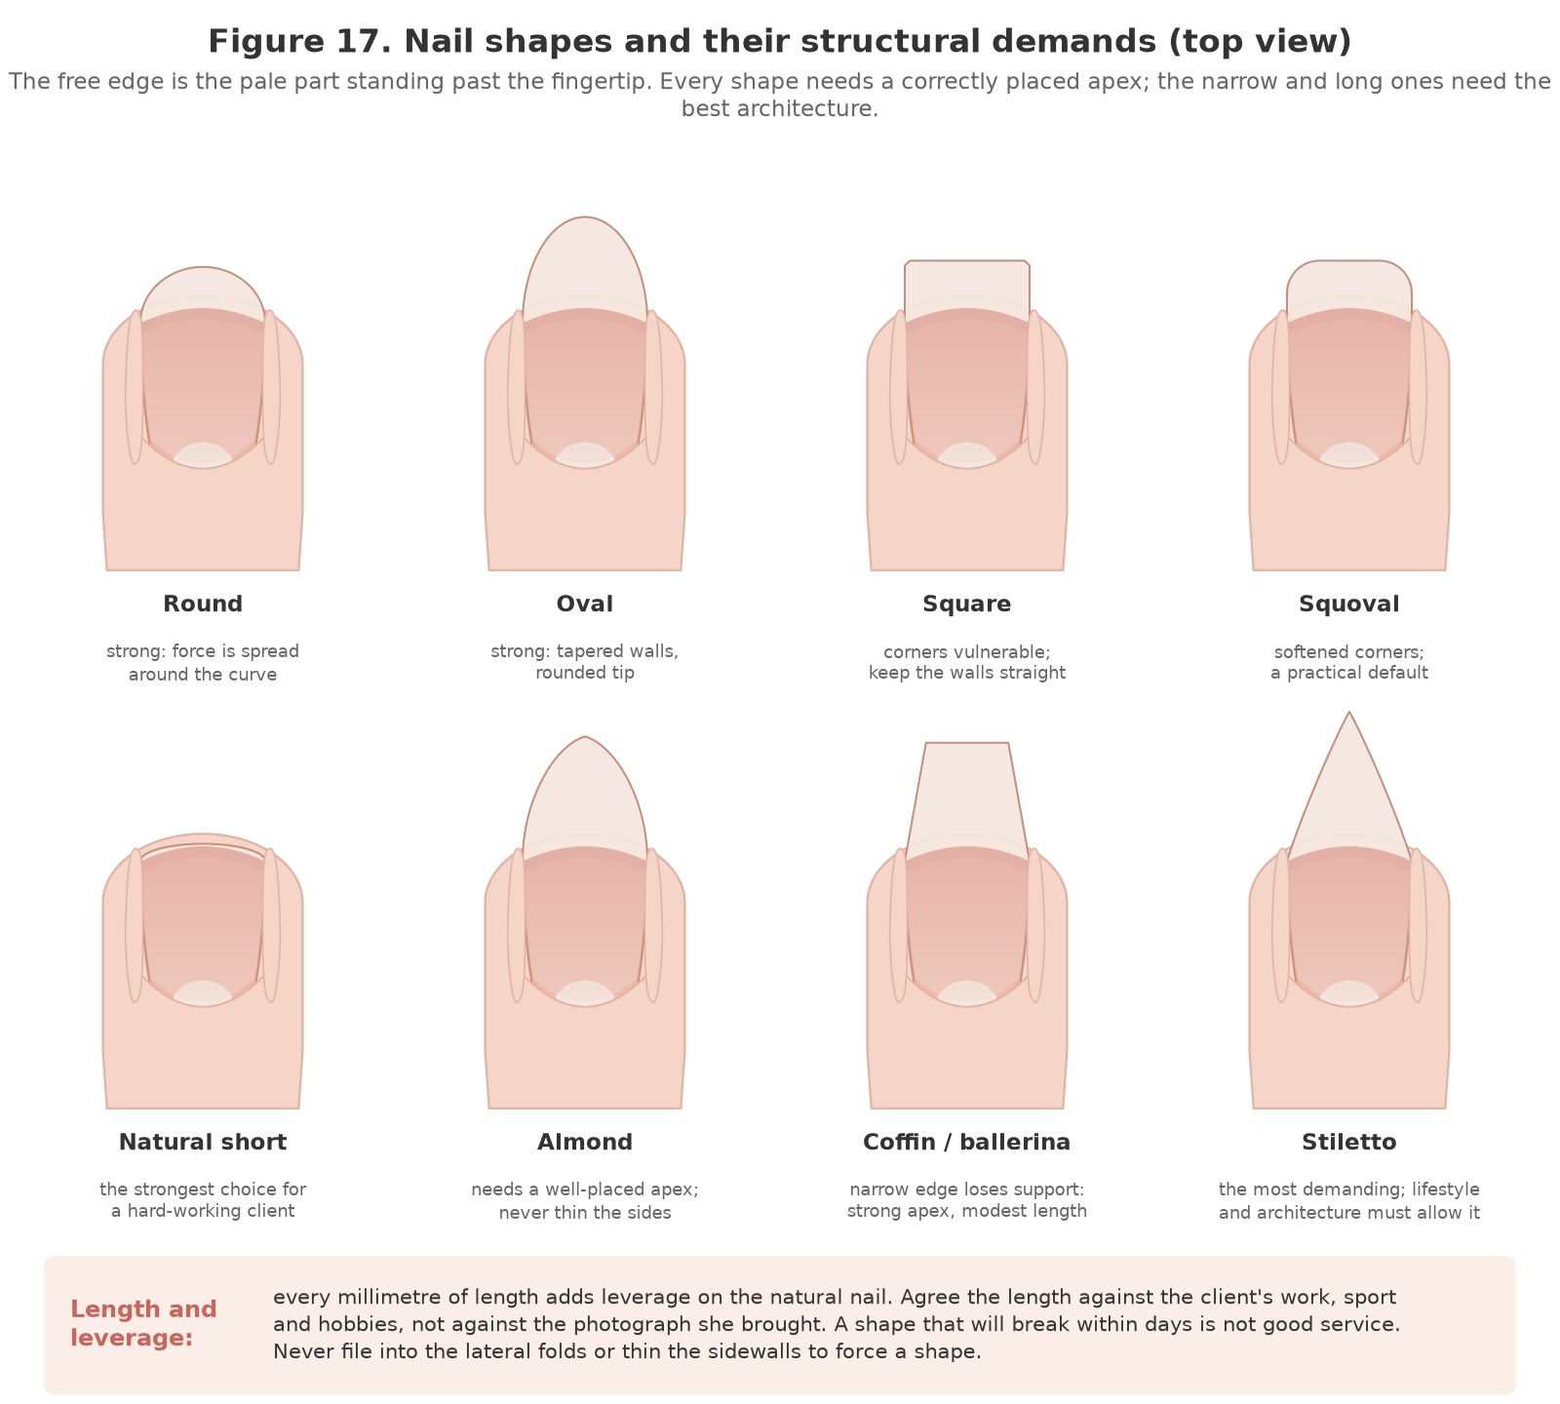
Figure 17. Nail shapes and their structural demands. Every millimetre of length adds leverage on the natural nail; the narrow and long shapes need the best architecture and a client whose lifestyle allows them.
Original illustration © The Looking Glass Beauty School, 2026.

Chapter 8 — Kit, brushes, forms, tips, files and product storage
Select the right tool, use it lightly and maintain it correctly

Core application kit
Item | Purpose and safe use
Acrylic brush | Kolinsky sable or synthetic, sizes 8 to 12 for general work; the course brush is a size 8 Kolinsky (see the section below). The brush shapes the bead; it is not a scrubbing tool. Never rest a brush on its bristles or clean it in acetone.
Dappen dish | Holds a small working amount of monomer. Use a lidded glass or purpose-made dish, keep it covered when not in use to limit vapour, and never return used liquid to the bottle.
Polymer powder | Keep pots closed. Decant a working amount rather than dipping repeatedly into a large pot. Contaminated powder ruins the set.
Liquid monomer | Store upright, capped, away from heat and direct sunlight. Keep the Safety Data Sheet accessible.
Nail dehydrator | Removes surface moisture immediately before product. Apply to the plate only.
Primer | Acid-free primers are standard for most systems. Acid primers are corrosive to skin and should only be used where the manufacturer requires it, with appropriate control measures.
Tips and tip adhesive | Fitted sidewall to sidewall. Adhesive is a cosmetic product with its own hazards; keep away from skin and eyes.
Sculpting forms | Fitted under the free edge with no gap. Single use.
Files and buffers | See the grit table below. Single-client use or fully decontaminated between clients.
Lint-free wipes | Single use, one nail at a time. Never move contamination from nail to nail.
Dust brush | Soft, cleaned regularly. Brushing dust into the air is not dust control.
Local extraction | A source-capture extractor at the working point, not a desk fan. See Chapter 9.

The acrylic brush: Kolinsky sable
The brush picks up the bead, carries it to the nail and shapes it, so its quality and condition show in every nail you build. Kolinsky sable is the traditional choice for liquid-and-powder work. The natural hair is flexible and resilient, holds monomer well and returns to a point after each stroke, and a brush that is looked after keeps its shape for a long time. A good acrylic brush has a fine, tapered point for detail at the cuticle area and sidewalls, and a fuller belly that holds the liquid and does the pressing and smoothing.
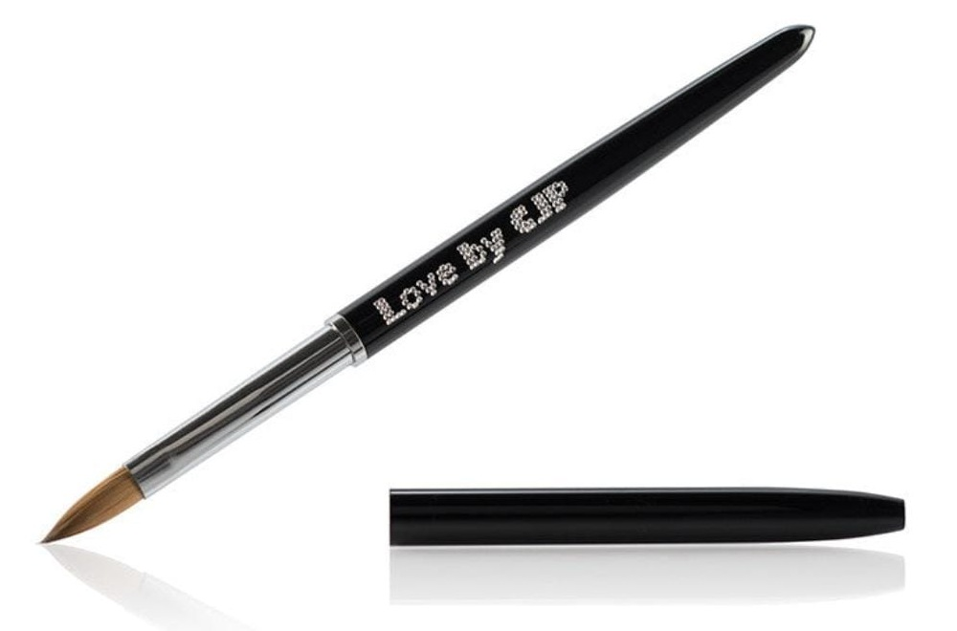
The brush used on this course: a CJP Love size 8 Kolinsky sable acrylic brush, shown with its protective cap.
Product image reproduced with permission. Love by CJP is a trade mark of its owner.
The brush used on this course is the CJP Love size 8 Kolinsky sable brush: natural Kolinsky hair in a metal ferrule on a balanced black handle, supplied with a protective cap. Size 8 is a versatile size that suits technicians who work with smaller beads and want precise control, which is how bead control is taught on this course.
BRUSH SIZE IS NOT THE RATIO — A larger brush picks up a larger bead, but it does not set the liquid-to-powder ratio for you. Follow the acrylic system manufacturer's instructions and judge the consistency of every bead as you work (Chapter 6).

Preparing a new Kolinsky brush
A new Kolinsky brush is usually supplied with a protective gum or starch-like coating in the hair, which holds its shape during manufacture and transport. Remove it before the brush goes near product:
- Gently loosen the hair and remove all of the protective residue, including from the belly of the brush.
- Saturate the hair with clean monomer that is compatible with your system.
- Press out the excess on a clean, lint-free disposable pad.
- Reshape the hair to its natural point.
Residue left in the brush makes the hair split and separate, and the brush will not pick up or place a bead cleanly.

Cleaning, maintenance and storage of the brush
- Clean the brush throughout each service with compatible monomer and a clean disposable pad. Never let acrylic harden in the hair or the ferrule.
- Do not pull, twist or scrape the hair to remove product.
- At the end of the service remove all visible product, clean the brush in fresh monomer and reshape it to a point.
- Do not use acetone or strong cleaning chemicals unless the brush manufacturer specifically allows it.
- Replace the protective cap carefully so that no hair is bent or trapped.
- Store the brush as its manufacturer directs. The CJP Love brush is stored with the hair pointing downwards; it is never left standing on its bristles.
- Keep the brush protected from dust and contamination between services.
The brush must be kept in a hygienic condition and used in line with the salon's infection prevention procedures. Cleaning in monomer removes product; it is not disinfection and must not be treated as one.

Professional practice
A well-maintained brush supports accurate placement, controlled beads and strong, balanced enhancements, but it does not replace technique, manufacturer-approved products and consistent hygiene. On this course you are expected to show safe handling of the brush, correct brush technique, control of the product and proper brush care as part of your practical training.

Files and grits
A lower number is a coarser file. Coarse files are for product only. The natural nail plate is never shaped with a coarse file.
Grit | Category | Typical use
80–100 | Very coarse | Reducing bulk on cured product only. Never on the natural nail.
100/180 combination | Coarse / medium | The standard enhancement file: 100 side for shaping product, 180 side for refining. This is the file used on this course.
180–240 | Medium to fine | Refining the surface and shaping the free edge.
240+ and buffers | Fine to very fine | Smoothing before finish. Light pressure only.
Sponge buffer block | Varies | Conforms to the surface. Check the printed grit. Single-client use.

ELECTRIC FILES — An electric file is not taught or assessed on this course. Using one on the natural nail without separate, specific training causes rings of fire, plate thinning and burns. If your school offers e-file training, it is a separate activity with its own assessment.
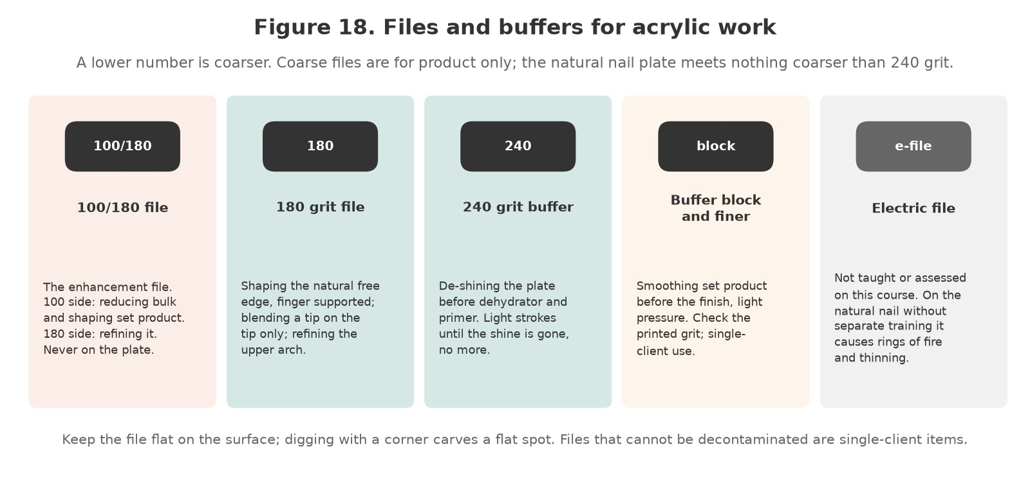
Figure 18. Files and buffers for acrylic work. The 100/180 is for set product only; the natural nail plate meets nothing coarser than 240 grit, and the electric file is outside this course.
Original illustration © The Looking Glass Beauty School, 2026.

Storage, decontamination and disposal
- Store monomer and powder according to the Safety Data Sheet: cool, dark, upright, away from ignition sources.
- Keep products in their original labelled containers. Decanting into unlabelled pots breaches COSHH and hides the hazard information.
- Clean brushes with monomer only, reshape, cap and store as the brush manufacturer directs. The course brush is stored with the hair pointing downwards, never resting on its bristles.
- Decontaminate reusable metal tools by cleaning then disinfecting or sterilising according to the risk assessment. Files that cannot be effectively decontaminated are single-client items.
- Dispose of monomer-soaked wipes in a lidded metal or fire-retardant bin, emptied daily. Do not leave saturated wipes open on the desk.
- Check expiry dates. Old monomer sets unpredictably.
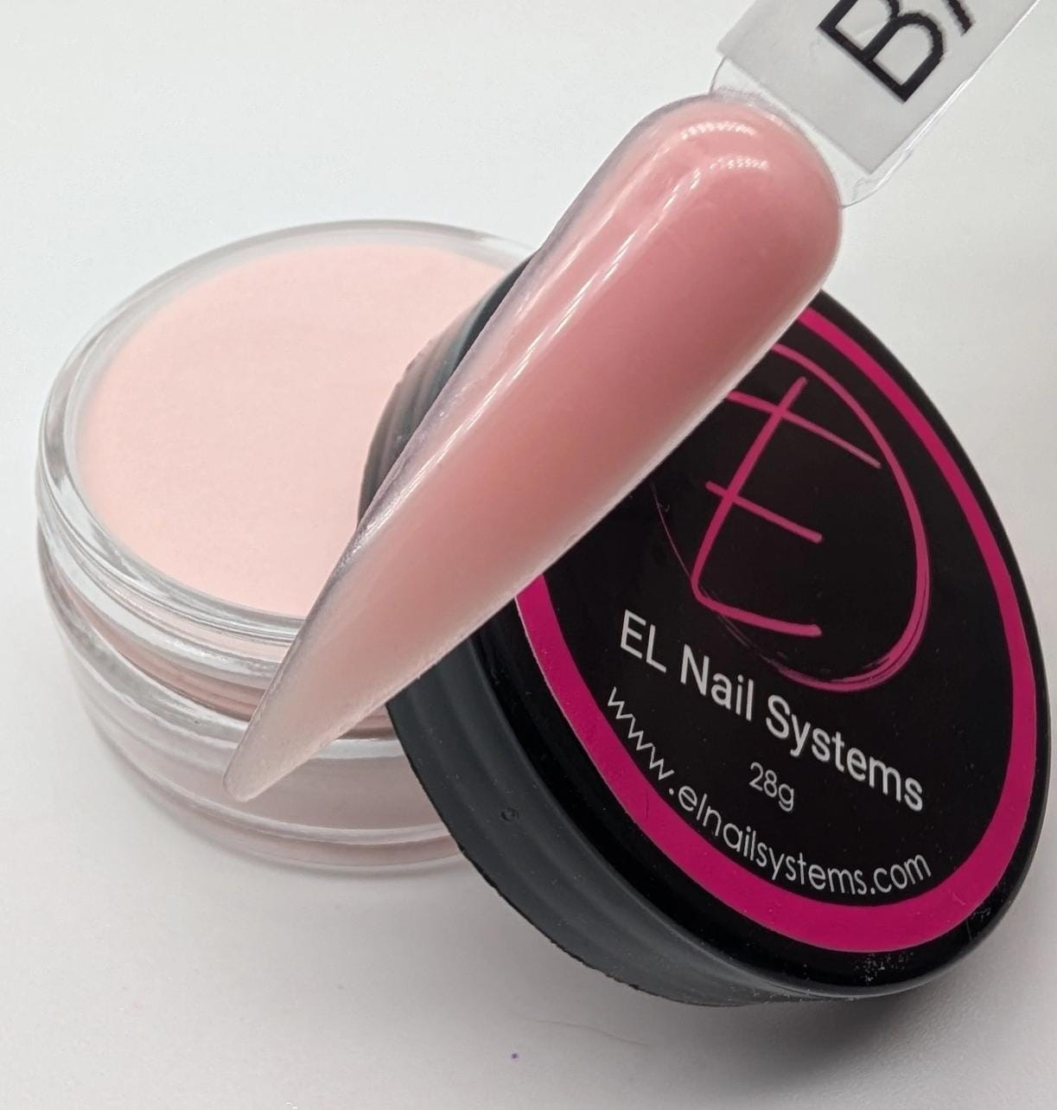
The acrylic system used on this course: a professional EMA powder in its labelled pot, with a sculpted sample of the same product. Any complete system from one manufacturer, a monomer and powder designed to be used together, can be used in the same way; record the actual product on Form G and on every client card.
Product image © The Looking Glass Beauty School, 2026. EL Nail Systems is a trade mark of its owner.

Chapter 9 — Health, safety, hygiene and ergonomics
Preventing exposure, cross-contamination and avoidable injury

Risk assessment and hierarchy of controls
The safest approach removes or reduces a hazard before relying on personal protective equipment. A salon COSHH/risk assessment should consider the product, task, route of exposure, frequency, quantity, ventilation, people at risk and emergency action.
Control level | Acrylic example
Eliminate | Do not stock a recalled/non-compliant product; do not perform an unsafe service.
Substitute | Select a professional compliant system with clear safety information where this reduces risk, while recognising that 'HEMA-free' is not allergy-free.
Engineering control | Use suitable local exhaust/downdraught extraction for dust and adequate general ventilation.
Administrative control | Training, consultation, thin application, closed containers, cleaning schedules, limited exposure time and incident reporting.
PPE | Task-appropriate gloves, eye protection and apron where the assessment/SDS requires them. PPE is the last line, not the only control.
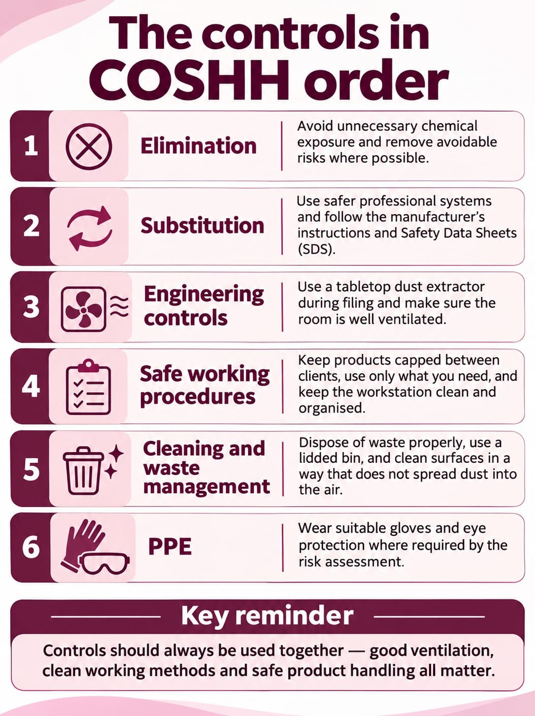
The hierarchy of controls as a working checklist for the acrylic workstation. The table above groups safe working procedures with cleaning and waste as administrative controls; here they are shown as separate steps. Work from the top: PPE is the last control, never the first.
Original artwork © The Looking Glass Beauty School, 2026.

Routes of exposure
Route | Examples | Control
Skin | Monomer, wet product, primer, dehydrator, acetone, filing dust, contaminated gloves | No skin contact; controlled application; prompt washing; suitable gloves; hand care
Eyes | Splash, dust, contaminated fingers | No touching face; eye protection for splash/dust tasks; eyewash access; follow SDS first aid
Inhalation | Fine filing dust, vapours and aerosols | Avoid unnecessary dust; local extraction; ventilation; closed containers; suitable RPE only where risk assessment requires
Ingestion | Eating/drinking at workstation, contaminated hands | No food/drink/smoking in treatment area; wash hands before breaks
Injection/cut | Nipper/file injury or contaminated sharp | Protect skin, use tools correctly, stop bleeding service and follow blood-spill procedure

Cleaning, disinfection, sanitation and sterilisation
These terms are not interchangeable. Cleaning physically removes dirt and organic matter and must occur before effective disinfection or sterilisation. Sanitation reduces contamination to an acceptable routine level. Disinfection inactivates many disease-causing microorganisms but may not destroy bacterial spores. Sterilisation is a validated process intended to destroy all viable microorganisms, including spores.
Item/method | Correct approach
Hands/skin | Wash with liquid soap and water when visibly dirty and at the start/end of work; dry thoroughly. Use an appropriate hand rub on visibly clean hands where policy allows. Moisturise between services/after work to protect the barrier.
Work surface, extractor and dappen dish | Clean visible soil, then apply a compatible disinfectant for the stated contact time. Do not spray liquid into the extractor's electrical parts.
Porous files, buffers, orangewood sticks | Treat as single-client/single-use unless the manufacturer and local policy provide a validated decontamination route. Do not share between clients.
Metal pusher, nippers, clippers | After every client: safely transport as used, clean with detergent/mechanical action, rinse/dry, inspect, then disinfect using a compatible product at correct dilution/contact time. Sterilise by validated steam autoclave if the risk assessment/local authority requires it.
Blood-contaminated reusable tool | Stop, wear appropriate PPE, quarantine safely and follow the blood/body-fluid procedure. Dispose as appropriate or use a validated cleaning and steam-sterilisation route; do not simply wipe and reuse.
Autoclave | Steam steriliser used only for compatible instruments with validated cycles, packaging/loading, records, routine tests and maintenance. It is the recognised salon method when sterilisation is necessary.
UV cabinet/light box | Storage aid for already clean/decontaminated instruments. It must not be described as a reliable steriliser.
Glass-bead unit, hot-air oven, boiling water | Do not present as validated salon sterilisation. Current local-authority guidance commonly states that glass-bead units, UV boxes, hot-air ovens and boilers must not be used for sterilisation.
Chemical immersion | Usually disinfection in salon use. A product may make a sterilant claim only under specific validated conditions; follow label, COSHH and local rules and do not casually call a disinfectant 'sterilising solution'.

Standard between-client sequence
- Remove used disposables and place them directly into the correct waste container.
- Move reusable tools to a designated closed 'used' container; keep them separate from clean tools.
- Clean and disinfect the workstation, hand rest, extractor touch points, dappen dish and any reusable containers using the correct contact time.
- Perform the full tool-cleaning and disinfection/sterilisation process. Dry, inspect and store protected.
- Wash and dry hands, replace couch roll/towel and set out only the clean items needed for the next client.
- Record completed scheduled cleaning and any contamination incident.

Blood or skin-break procedure
- Stop the service and move products/tools away.
- Ask the client to apply pressure with clean disposable gauze where appropriate; the professional should wear suitable disposable gloves.
- Do not continue product application over broken skin or active bleeding.
- Dispose of contaminated single-use materials in the route identified by the local waste assessment. Quarantine reusable tools for validated processing.
- Clean and disinfect the contaminated surface using the salon's blood-spill procedure and product instructions.
- Wash hands after glove removal, document the incident and provide appropriate first-aid/referral advice.

Ventilation, dust and odour
HSE guidance for nail bars and beauticians (HSE COSHH Essentials sheet SR13, "Nail bars and other beauty services") identifies dermatitis, skin allergy, asthma and respiratory symptoms as relevant risks from beauty products and artificial-nail dust. General ventilation helps, but opening a window alone may not control dust at the technician's breathing zone. Use source capture where the assessment requires it, maintain filters and use methods that create the least dust.
- Keep bottles closed when not dispensing and clean spills immediately according to SDS.
- Position local extraction close enough to capture dust before it crosses the breathing zone.
- Do not rely on a strong smell to judge danger; some hazardous exposure has little odour, and smell perception varies.
- Do not use an ordinary desk fan that blows dust and vapour across the client or room.
- Empty/maintain extraction and waste in accordance with instructions while wearing any identified PPE.

Ergonomics and prevention of backache/RSI
Area | Good practice
Chair and feet | Use an adjustable supportive chair. Sit back with feet flat or on a footrest; avoid perching or twisting.
Desk and elbows | Use a narrow, stable manicure desk so client and technician do not reach. Support both forearms; aim for relaxed shoulders and elbows near 90 degrees.
Neck and vision | Bring the client's hand into the lit working area instead of bending the neck toward the desk. Consider task lighting or magnification.
Wrist and grip | Keep wrist as neutral as possible, use a light tool grip, support the finger and vary movement. Replace worn files rather than pressing harder.
Client position | Seat the client squarely facing the desk with supported arm and relaxed hand. Ask them not to pull, twist or hold the fingers rigid.
Work pattern | Insert microbreaks, stretch hands/forearms/neck, alternate tasks, schedule realistic service gaps and review symptoms early.
Warning signs | Persistent pain, tingling, numbness, weakness or night symptoms require workload review and appropriate medical/occupational-health advice.

30-SECOND POSTURE RESET — Feet supported; hips back; shoulders down; client close; forearms supported; wrist neutral; extraction correctly positioned. Reset between every client.

Dust and vapour — the two exposures specific to acrylic
Acrylic work produces two exposures that a gel-polish service does not: fine dust from filing cured product, and monomer vapour from the open dappen dish and the working bead. Both are controlled under COSHH, and both are the professional's own health as much as the client's.

Dust
- Filing dust from enhancements is fine enough to be breathed deep into the lungs, and it can contain product that has not fully reacted.
- Use source capture — an extractor at the point of filing that draws dust away from both faces. A desk fan moves dust around; it does not remove it.
- A paper or fabric face covering is not respiratory protection. Where the risk assessment requires it, use a properly fitted FFP2 or FFP3 respirator.
- Wipe surfaces with a damp cloth rather than brushing dust into the air. Vacuum with a suitable filter; do not sweep.
- Clean the extractor filter on the manufacturer's schedule and record it. A blocked filter is not a control measure.

Vapour
- Keep the dappen dish lidded whenever you are not drawing from it.
- Decant only the amount you need for the client in front of you.
- Ventilate the room: general ventilation plus source capture at the workstation.
- Close product bottles immediately after use.
- Dispose of monomer-soaked wipes in a lidded bin, emptied at the end of every day.
YOUR OWN EXPOSURE — A client is exposed for two hours a fortnight. You are exposed every working day. Sensitisation ends nail careers; the controls in this chapter exist mainly to protect you.
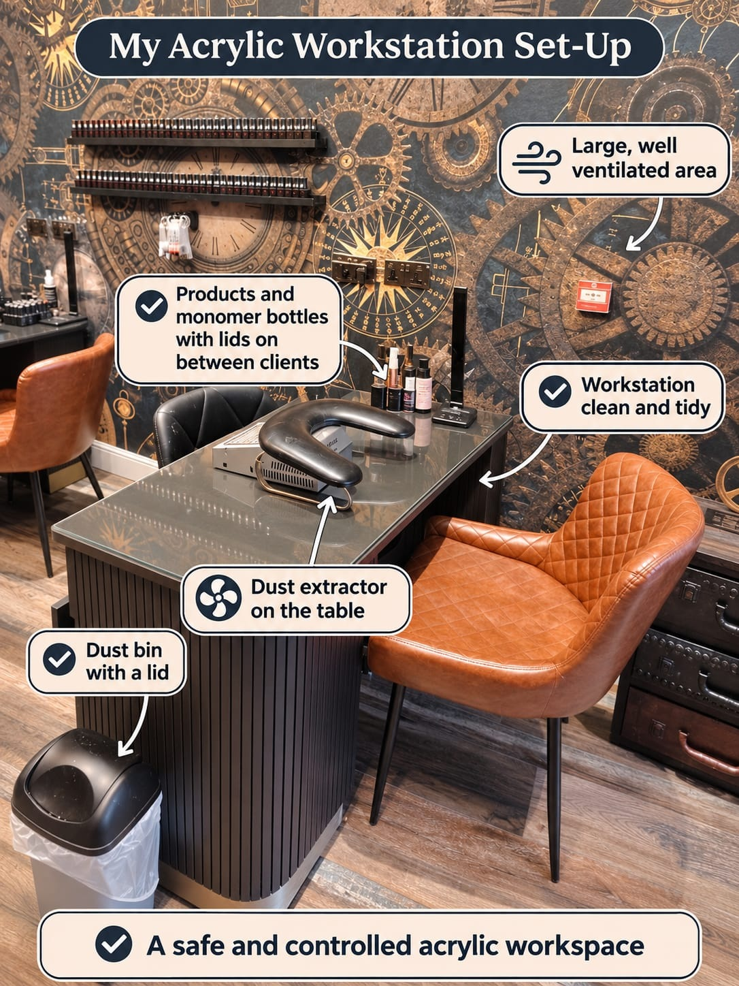
Figure 19. Dust and vapour controls at a working acrylic station: a large, well-ventilated area, a dust extractor on the table at the point of filing, products and monomer bottles with their lids on between clients, a clean and tidy surface and a lidded bin. General ventilation supports the extractor and does not replace it. A desk fan is not a control.
Original photographs and artwork © The Looking Glass Beauty School, 2026.

Chapter 10 — UK legislation, insurance, data and advertising
How the rules connect to everyday salon decisions
Legislation changes and local requirements differ. The following summary explains relevance to acrylic enhancement work in Great Britain as at October 2026; it is educational guidance, not legal advice. Businesses must check current official sources, insurer terms and their own local authority before delivery and at each document review.

Core legislation and guidance
Law or requirement | Relevance to an acrylic professional
Health and Safety at Work etc. Act 1974 | Creates general duties to protect employees and others, including clients, so far as reasonably practicable. In practice: risk assessments, safe systems, training, maintained equipment, consultation and incident action.
Control of Substances Hazardous to Health Regulations 2002 (COSHH) | Requires employers to assess and prevent or adequately control exposure to hazardous substances. Keep SDS, identify skin/inhalation/eye/fire risks, use control measures, train staff, manage spills and review assessments when products or processes change.
Personal Protective Equipment at Work Regulations 1992, as amended in 2022 | Where risk remains after other controls, employers must provide suitable PPE free of charge, train workers and maintain it. The 2022 amendment extends relevant duties to limb (b) workers. PPE selection must follow the hazard and SDS, not salon fashion.
Reporting of Injuries, Diseases and Dangerous Occurrences Regulations 2013 (RIDDOR) | Specified work-related injuries, dangerous occurrences and diagnosed occupational diseases must be reported by the responsible person. Not every chip, rash or complaint is RIDDOR-reportable. Work-related diagnosed dermatitis can be reportable where the work involves significant/regular exposure to skin irritants or sensitisers. Use HSE's current decision guidance.
Data Protection Act 2018 and UK GDPR | Client contact details, consultation records, health information and photographs are personal data; health data is special-category data. Identify an Article 6 lawful basis and an Article 9 condition, give privacy information, minimise collection, secure records, set justified retention periods, support rights and separate treatment consent from marketing consent.
Cosmetic Products Enforcement Regulations 2013 and retained Cosmetic Regulation 1223/2009, as amended | Cosmetic nail products supplied in GB must meet safety, responsible-person, labelling and notification requirements. Buy through reputable compliant supply chains, keep original labels/batches, act on recalls and do not manufacture, relabel or import products without understanding responsible-person obligations.
Cosmetic Products Regulation (Restriction of Chemical Substances) (Amendment and Transitional Provisions) Regulations 2026 (SI 2026/23, as supplemented by SI 2026/109) — TPO | TPO is a photoinitiator used in light-cured gel products, not in liquid-and-powder acrylic; the entry is here because most acrylic professionals also stock gel polish or a gel top coat. GB restrictions on TPO begin on 15 August 2026 with transitional provisions for products already placed on the market; existing compliant stock may continue to be made available to 14 February 2027. TPO has been banned in the EU and Northern Ireland since 1 September 2025. Check current OPSS/Trading Standards and supplier guidance before purchase or use.
Local Government (Miscellaneous Provisions) Act 1982 | In England outside London, local authorities can adopt licensing/registration provisions for specified treatments and may impose local byelaws or special-treatment conditions. Coverage differs between authorities, so each business and learner must check the authority where they practise and meet insurer requirements.
London Local Authorities Act 1991 | In London, premises offering nail treatments generally need a Special Treatment Licence, applied borough by borough with local conditions on qualifications, hygiene and premises. Check the relevant borough before trading.
Civic Government (Scotland) Act 1982 | In Scotland, licensing of relevant treatments and premises operates under this Act through the local licensing authority. Check the authority where you practise.
Public Health (Wales) Act 2017 | In Wales, this Act established a special-procedures licensing framework. Nail services are not currently within the mandatory licensing categories, but practitioners in Wales must check current Welsh Government and local-authority guidance.
Electricity at Work Regulations 1989 | Electrical systems and work equipment must be maintained to prevent danger and used safely. Visually check the extractor, any lamp used for a gel top coat, leads and plugs; keep liquids away; remove faults from use and arrange competent inspection/testing based on risk. The law does not automatically demand annual PAT testing for every appliance.
Waste Electrical and Electronic Equipment Regulations 2013 (as amended) | Extractors, lamps and other electrical equipment must enter an appropriate WEEE reuse/recycling route when discarded. Do not place electrical items in normal waste; use supplier take-back or an authorised business-waste route and retain records where required.
Consumer Rights Act 2015 | Services must be performed with reasonable care and skill, information relied on by the consumer can become binding, and pricing must be clear. Avoid unrealistic guarantees and maintain complaint/rectification procedures.
Employers' Liability (Compulsory Insurance) Act 1969 | Most businesses employing staff must hold employers' liability insurance meeting legal requirements and display/make the certificate accessible. This is separate from public and treatment liability.
Workplace (Health, Safety and Welfare) Regulations 1992 | Relevant to safe, clean and suitable workplaces, including ventilation, lighting, temperature, welfare and workstation conditions.
Equality Act 2010 | Service providers and educators must not unlawfully discriminate and should consider reasonable adjustments. Adjustments can change access or assessment method but cannot remove essential safety and competence standards.

Whatever the nation, always confirm licensing and registration requirements with your own local authority and your insurer before trading.

Public liability, treatment risk and product liability
Public liability insurance is not one of the Acts listed above, but it is an essential business control and may be required by venues, landlords, local authorities, training providers or contracts. A nail professional should confirm that cover includes the exact treatments, products, teaching activities, students/models, premises and working arrangements. Treatment/professional liability and product liability may be included or separate. Policy conditions often set qualification, age, consultation, record-retention, patch-testing and incident-notification requirements.
- Never assume the salon policy covers a self-employed professional or educator; obtain written confirmation.
- Notify the insurer promptly about an adverse reaction, injury, complaint or potential claim according to the policy. Do not admit liability or alter records.
- Keep factual, contemporaneous treatment and training records for the period agreed with the insurer and documented in the business retention schedule.
- If employing anyone, confirm employers' liability and health-and-safety duties in addition to public/treatment cover.

Data protection in consultation and case studies
Principle | Salon action
Transparency | Give a privacy notice explaining controller identity, purposes, lawful basis/condition, recipients, retention, security and client rights.
Data minimisation | Ask only what is necessary for safe treatment. A full GP address or unrelated medical history is normally unnecessary.
Health data | Document the relevant Article 6 lawful basis and Article 9 condition. Explicit consent may be available where genuinely appropriate, but treatment consent and data-processing conditions are different legal concepts.
Security | Lock paper files; use access-controlled, backed-up systems; avoid client details in personal messaging/photo galleries; restrict staff access.
Accuracy | Confirm changes at every appointment and record what the client said without turning observations into a diagnosis.
Retention | Use a written schedule based on purpose, insurer/legal advice and limitation periods; review and securely delete/anonymise when no longer needed.
Photographs | Use separate optional consent. State educational/assessment/marketing uses individually, avoid identifying features where possible and never post a case-study image automatically.
Breach response | Contain, assess, document and report qualifying personal-data breaches to the ICO within required timescales where applicable; inform affected people when high risk requires it.

Advertising Standards Authority (ASA) and CAP guidance
Advertising includes websites, booking pages, social media, paid posts, influencer content, leaflets and claims made in before/after images. The ASA/CAP position is that beauty marketers must hold evidence for objective efficacy claims and must not exaggerate effects.
Avoid | Use instead
'Guaranteed not to lift for three weeks' | 'Designed to last between infills; individual wear varies with nail condition, lifestyle and aftercare.'
'Repairs weak or damaged nails' | 'Adds strength and length over the natural nail. It does not diagnose or treat the cause of nail weakness.'
'Completely safe', 'non-toxic' or 'allergy-free' | Describe specific product information accurately and acknowledge that adverse reactions are possible.
'Treats fungus', 'kills infection' or 'cures green nail' | State that suspected infection cannot be treated cosmetically and requires medical/pharmacy advice.
'Qualified nail technician' based only on this CPD activity | 'Completed the Liquid and Powder Acrylic Enhancement CPD Course' alongside the learner's genuine underlying qualification.
Heavily retouched before/after images or inconsistent lighting | Use comparable lighting/angle, retain originals, obtain consent and disclose relevant editing/filters.
'Best', 'number one' or award claims without evidence | State the exact verifiable award, year and category; do not imply a wider win than was achieved.

ASA RESOURCE — Learners should review the current ASA/CAP 'Beauty and Cosmetics: General' guidance before advertising: https://www.asa.org.uk/advice-online/beauty-and-cosmetics-general.html

Electrical and extraction checklist
- ☐ The extractor, and any lamp used for a gel top coat, is obtained from a reputable supplier and is suitable for the task.
- ☐ Plug, cable, adaptor, housing and timer show no damage, heat marks or exposed parts.
- ☐ The extractor filter is clean and changed on the manufacturer's schedule, and the change is logged.
- ☐ The equipment is kept away from liquids and connected without unsafe adaptors or trailing-trip hazards.
- ☐ User checks, inspection/test intervals and maintenance are based on risk and recorded; an arbitrary annual sticker is not treated as the only control.
- ☐ Faulty equipment is unplugged, labelled and removed from use pending competent repair or WEEE disposal.

Chapter 11 — Preparing the natural nail for an enhancement
Adhesion is won or lost here
Almost all lifting is a preparation failure, not a product failure. The plate must be clean, dry, free of oil and free of loose non-living tissue, with no product on the living skin.

Preparation sequence
- Sanitise your own hands and the client's hands. Inspect every nail and the surrounding skin before you touch a product.
- Remove any existing product or polish. Do not begin preparation over old product.
- Shorten and shape the free edge to the agreed length using a 180 grit file, supporting the finger and filing in one direction where the plate is fragile.
- Gently push back the proximal nail fold with a rubber-tipped or wooden tool. Do not cut living tissue and do not force the tool under the fold.
- Remove only loose, non-living cuticle tissue adhering to the plate, using the least abrasive method that works.
- Remove the surface shine from the plate with a fine buffer (240 grit or finer), using light strokes. This is de-shining, not thinning. Do not etch grooves and do not use a coarse file.
- Remove dust with a clean brush, then cleanse the plate with the product specified by the system.
- Apply dehydrator to the plate only, and allow it to flash off.
- Apply primer sparingly to the plate only, following the manufacturer's instruction. More primer does not mean more adhesion.
- Work on one hand at a time so the prepared plate does not sit exposed and re-oil before product goes on.
NEVER FILE THE PLATE TO CREATE GRIP — Thinning the natural nail does not improve adhesion; it weakens the plate and makes the client dependent on the enhancement. Correct cleansing and dehydration do the work.
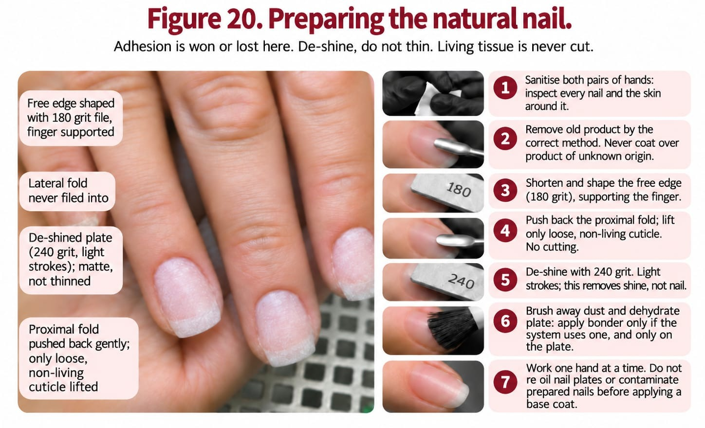
Figure 20. Preparing the natural nail for an enhancement: the free edge shaped, the fold pushed back, only loose non-living cuticle lifted, the plate de-shined with 240 grit, dehydrator and primer on the plate only, and a hairline gap kept at every fold.
Original photographs and artwork © The Looking Glass Beauty School, 2026.

Common preparation faults
Fault | Consequence
Cuticle tissue left on the plate | Product adheres to the tissue, not the nail; lifting at the base within days.
Oil or hand cream on the plate | Immediate adhesion failure.
Over-buffed, thinned plate | Sensitivity, weakness and a client who cannot go without product.
Primer or product on the living skin | Irritation, and a direct route to sensitisation.
Preparing all ten nails before starting product | The first nails re-oil before you reach them.

Chapter 12 — Tips and sculpting forms
Two ways to add length, both demanding an exact fit

Tips
- Select a tip that matches the width of the natural nail from sidewall to sidewall. If you are between sizes, take the larger and file the sidewalls down — never pinch a narrow tip on.
- Check the C-curve of the tip against the natural nail. A mismatched curve will lift.
- Apply a small amount of adhesive to the well of the tip, not the nail plate.
- Place at a shallow angle from the free edge, roll it down into position and hold until set, keeping adhesive off the skin.
- Blend the tip so the join cannot be felt, using a 180 grit file or buffer on the tip only. Filing through the join into the natural nail is the most common tip fault.
- Cut and shape to the agreed length before applying acrylic, holding the tip cutter at right angles to avoid shattering.
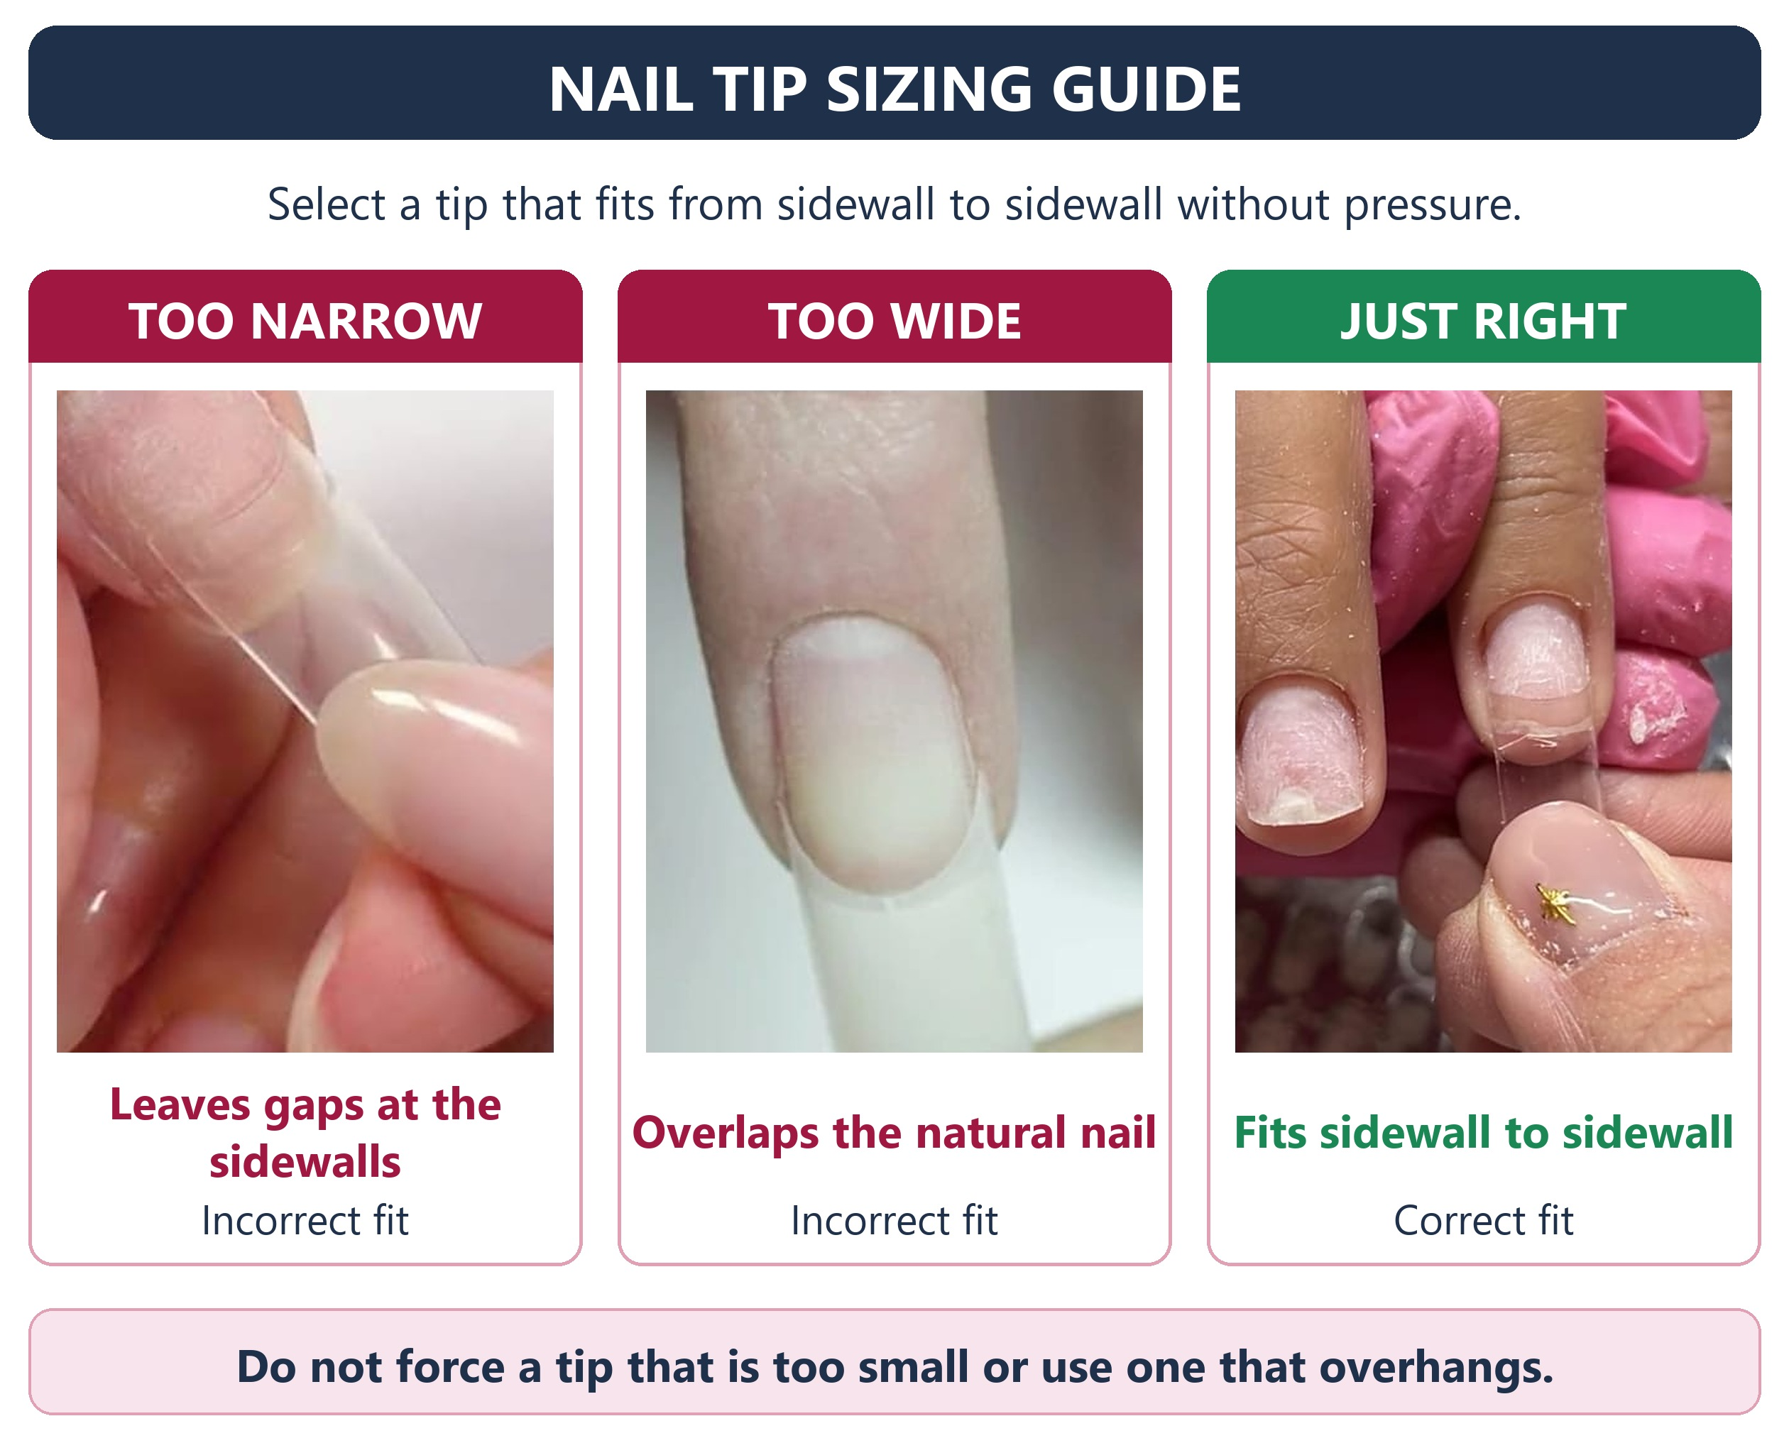
Figure 21a. Sizing a tip. Too narrow leaves gaps at the sidewalls and has to be pinched on; too wide overlaps the nail folds; the correct tip meets both sidewalls without pressure. Between sizes, take the larger and file its sidewalls down.
Original photographs and artwork © The Looking Glass Beauty School, 2026.

Sculpting forms
- Choose the form shape that suits the nail and the finished shape you have agreed.
- Fit the form under the free edge so it meets the hyponychium with no gap, and does not pinch the sidewalls.
- Check the angle from the side: the form should continue the line of the natural nail, not point up or drop away.
- Check from underneath that the form is symmetrical before applying any product.
- Apply product, allow it to set fully, then remove the form by unpeeling rather than pulling.
- Refine the underside and the free edge, checking the C-curve from the barrel view.
 | Tips | Forms
Speed | Generally faster to learn | Slower to learn, faster once fluent
Cost per client | Consumable tip plus adhesive | Consumable form only
C-curve control | Limited by the tip you select | Fully controlled by the professional
Common fault | Filing through the blend into the natural nail | Gap under the free edge letting product touch the hyponychium

NO GAPS — Whether tip or form, a gap under the free edge lets product touch living tissue and traps moisture. Check underneath before you pick up the brush.
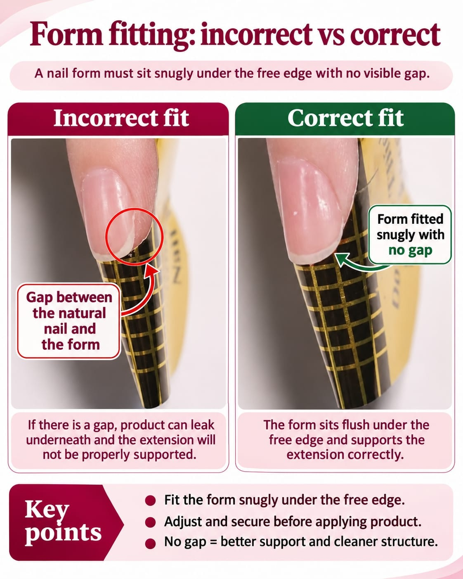
Figure 21b. Fitting a form. Left: a gap between the free edge and the form lets product run underneath and leaves the extension unsupported. Right: the form sits flush under the free edge with no gap and continues the line of the natural nail. Check from the side and from underneath before picking up the brush.
Original photographs and artwork © The Looking Glass Beauty School, 2026.

Chapter 13 — Acrylic application: bead control and building the structure
Placing product with intent

Setting up
- Decant fresh monomer into the dappen dish and keep it lidded between beads.
- Saturate the brush, then wipe one side on the lip of the dish to remove excess.
- Pick up the bead by touching the powder surface and holding briefly; do not stir or dig.
- Pause for a moment before placing: the bead should settle into a soft, domed shape on the brush.

Application sequence
- Place the first bead at the free edge or on the form, and guide it to the shape and length agreed. Do not press it flat.
- Place the structural bead over the stress area to build the apex. This is the bead that determines whether the nail survives.
- Place a small, wet-enough-to-flow bead at the cuticle area and guide it to a whisper-thin margin, leaving a hairline gap from the living tissue.
- Blend the zones with the belly of the brush using light, flowing strokes. Do not paint back and forth once the product has begun to set.
- Check the apex from the side and the C-curve from the barrel before the product sets hard.
- Allow the product to set fully — it should sound hard when tapped — before any filing.
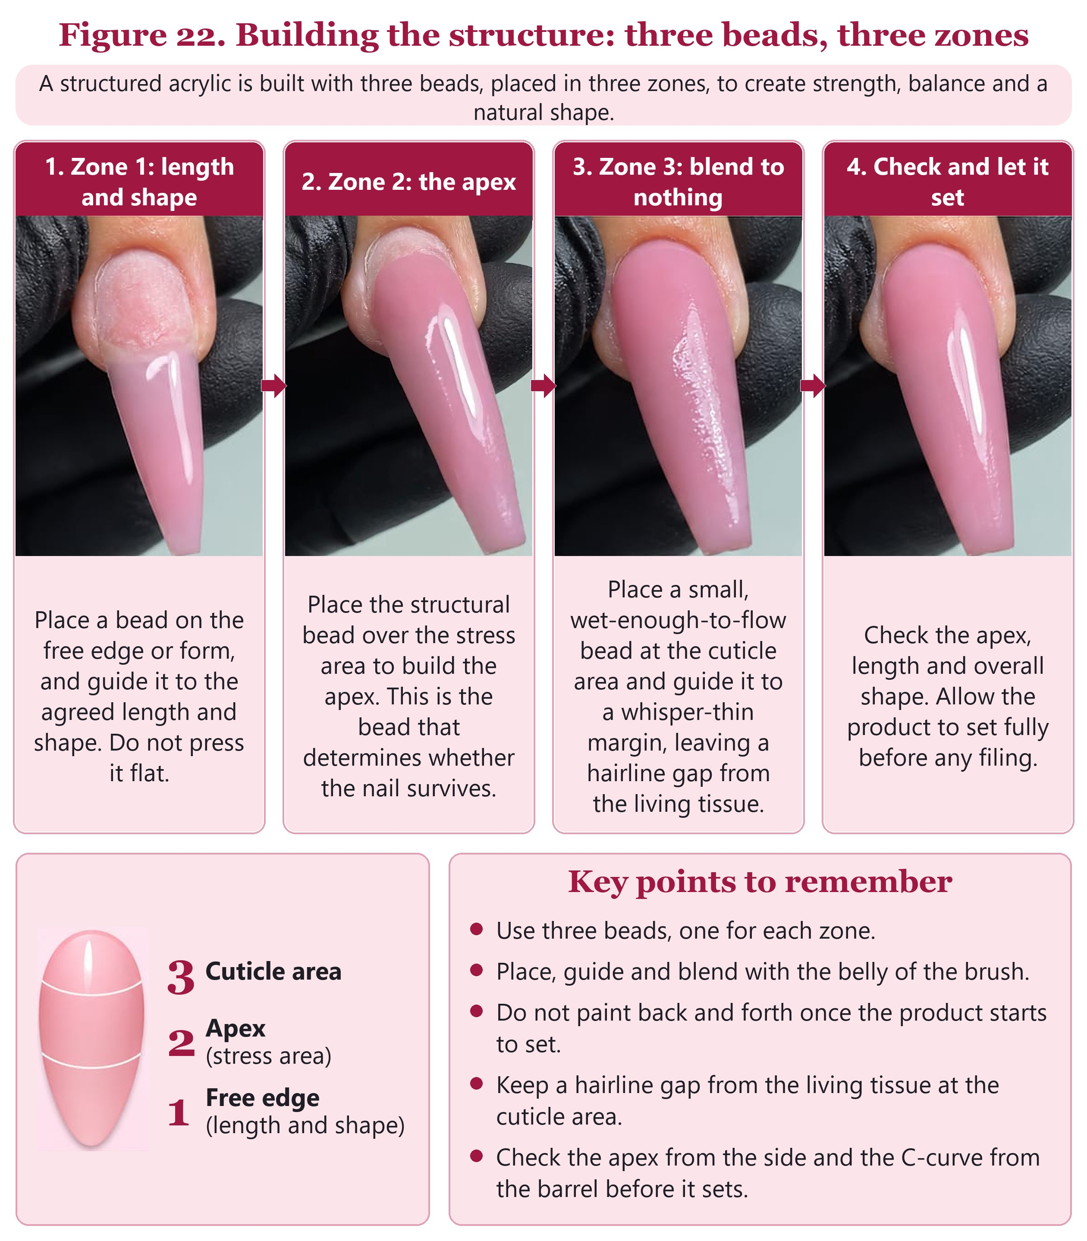
Figure 22. Building the structure in three zones: a bead for length and shape in zone 1, the structural bead over the stress area in zone 2, a small wet bead blended to nothing in zone 3 with a hairline gap, then the three checks before the product sets hard.
Original photographs and artwork © The Looking Glass Beauty School, 2026.
What Figure 22 shows. The four photographs follow one nail through the application sequence above. In the first, the natural nail has been prepared and the first bead has been placed at the free edge and guided out along the form to the agreed length and shape; it is stroked into place, not pressed flat, so the extension keeps its thickness. In the second, the structural bead has been placed over the stress area in the centre of the nail and is still wet and glossy, with the cuticle area not yet covered. This bead builds the apex, the highest and strongest point, and carries the load when the free edge is knocked. In the third, a smaller bead has been placed near the cuticle area and brushed back towards the fold until it thins to almost nothing, stopping a hairline short of the skin so that no product touches living tissue, and the three beads have been blended into one continuous surface. In the fourth, the nail is checked for apex, length and shape and left to set fully before any filing. The diagram beneath numbers the zones in the order they are worked: 1 at the free edge, 2 at the apex and 3 at the cuticle area. The key points repeat the rules that prevent the two commonest faults, lifting caused by product on the skin and breakage caused by a misplaced apex. Three beads is a teaching guide, not a fixed rule: a longer or wider nail may need more product in a zone, but the order and the purpose of each zone do not change.

Reading the surface as you work
What you see | What it means | What to do
The bead spreads on its own and floods the sidewalls | Ratio too wet | Wipe more liquid from the brush before picking up the next bead.
The bead will not smooth and shows crumbs | Ratio too dry | Carry slightly more liquid; check the powder is not contaminated.
Product creeps onto the cuticle area | Bead placed too close, or too wet | Remove it now with the brush. Do not rely on filing it off later.
The surface sets before you have shaped it | Room too warm, bead too large, or working too slowly | Use smaller beads and commit to the placement.
White or cloudy patches appear in the set product | Poor ratio or contamination | Remove and rebuild that section rather than covering it.

THE HAIRLINE GAP — Product must never touch the proximal nail fold, the lateral folds or the hyponychium. A deliberate hairline gap at the cuticle area is correct technique, not a flaw. It grows out invisibly; product on skin causes lifting and allergy.

Chapter 14 — Filing, refining and finishing
Shaping the structure you built
- Reduce and shape the free edge and sidewalls with the 100 grit side, keeping the file flat against the surface rather than digging with the corner.
- Establish the shape from above: straight sidewalls, symmetrical, matched across all ten nails.
- Refine the upper arch with the 180 grit side, blending the apex so there is no shelf or flat spot.
- Thin the cuticle area to a whisper, checking by touch as well as by eye.
- Check the C-curve from the barrel view and even it out.
- Refine the underside of any extension, removing product ledges.
- Buff through the grits to the finish the system requires, then remove all dust.
- Apply finishing oil or the product specified, and check every nail from four angles before the client leaves.
Finishing fault | How to see it | Fix
Flat spot where the apex should be | Side view under a light | Rebuild rather than file the surrounding area down.
Ledge at the cuticle area | Run a fingertip across the margin | Thin the margin; do not cover with more product.
Uneven sidewalls | Look straight down the nail | Re-file both walls, do not chase one side.
Over-thinned free edge | Hold to the light — it will glow | Rebuild. A translucent edge chips within days.
Dust left under the free edge | Barrel view | Brush and wipe before finishing.

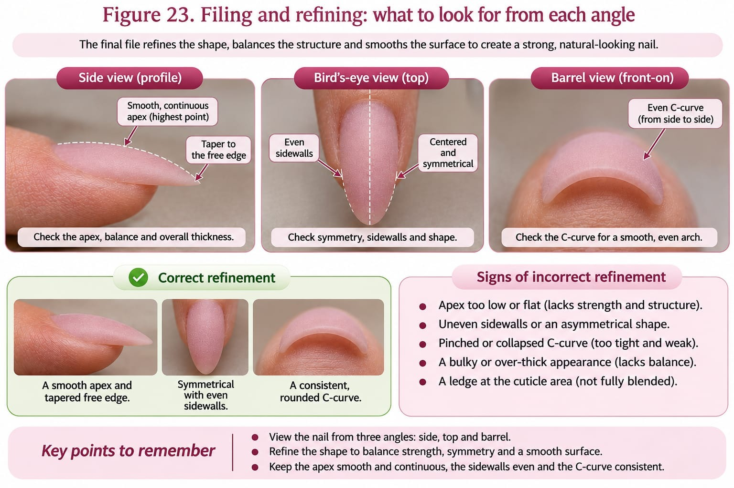
Figure 23. Filing and refining from each angle: the apex blended with no flat spot from the side, an even C-curve from the barrel, straight symmetrical sidewalls from above, and no ledges under the extension or at the cuticle margin.
Original photographs and artwork © The Looking Glass Beauty School, 2026.
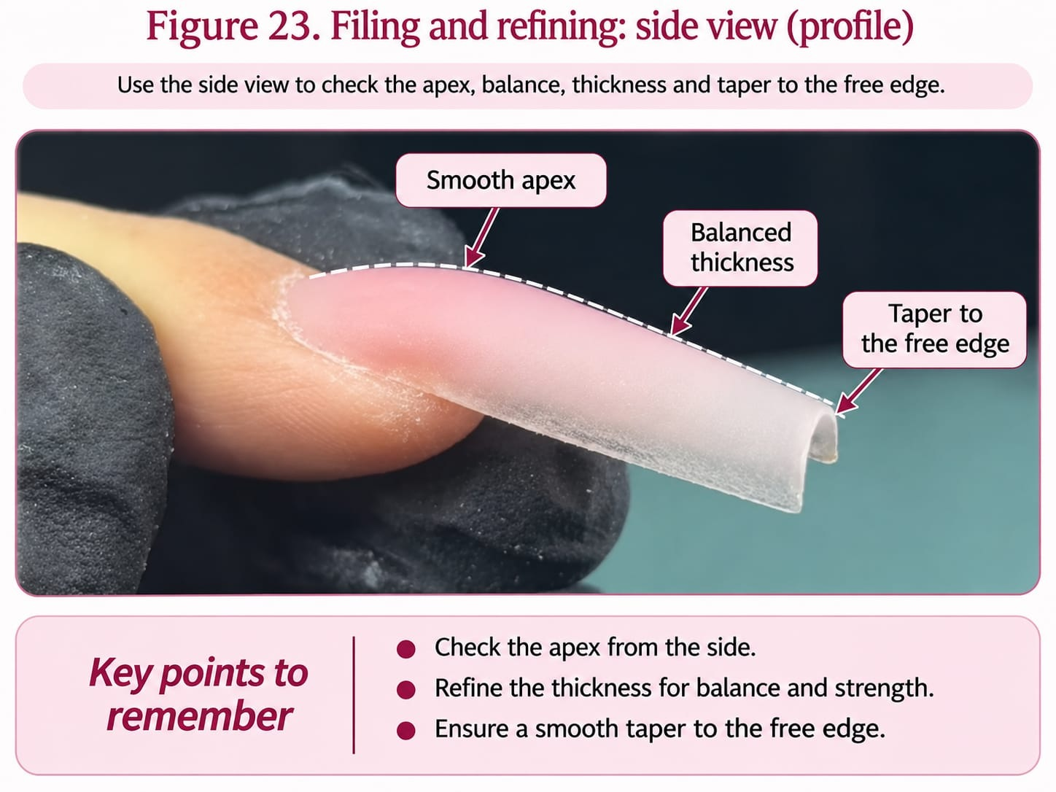
Figure 23 (side view). The profile of a filed and refined enhancement on a model: a smooth apex with no flat spot, balanced thickness along the length and an even taper to a slim free edge. The surface is matt because it has been filed and not yet buffed or finished.
Original photographs and artwork © The Looking Glass Beauty School, 2026.

Chapter 15 — Infills, rebalance, repairs and removal
Maintaining the structure, and taking it off safely
Figure 24. infill and Rebalance – 4–5 Weeks of Regrowth

This image shows a set of acrylic nail enhancements approximately 4–5 weeks after the previous appointment. Significant natural nail regrowth is clearly visible at the cuticle area, and the original apex has moved forward as the nails have grown. The enhancements now require an infill and structural rebalance to restore the correct apex position, strength and overall balance. Any lifting or damage must be assessed and addressed before new product is applied..
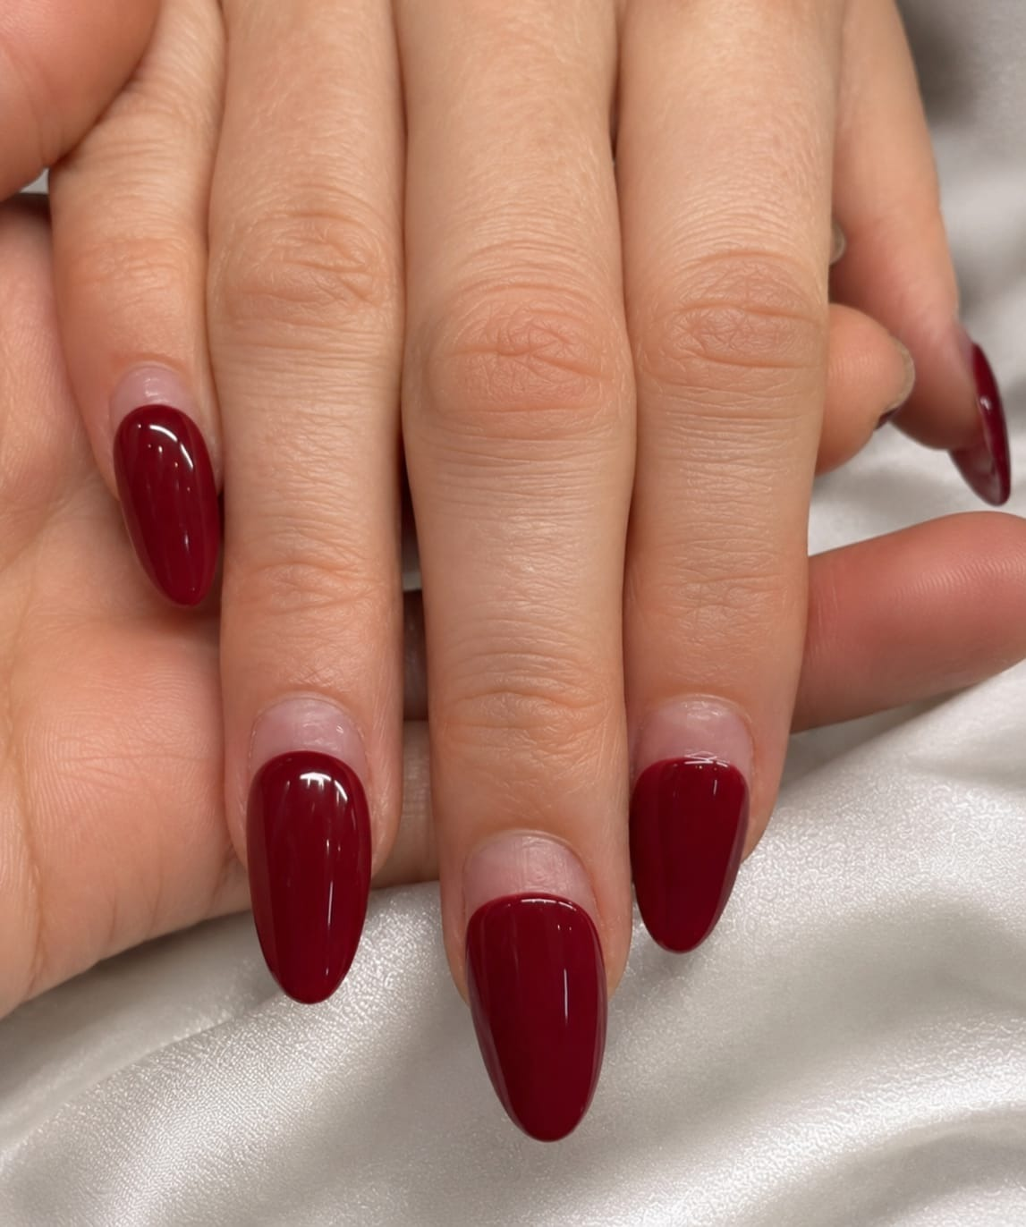
Photograph © The Looking Glass Beauty School, 2026.

Infill and rebalance
An infill fills the regrowth area. A rebalance moves the apex back to where it belongs as the nail grows forward. Every maintenance appointment should do both; filling the gap without rebalancing is what causes nails to break at the stress area after a few cycles.
- Assess every nail before touching a file. Record lifting, cracks, discolouration and any skin changes.
- Remove any lifted product completely. Never apply fresh product over a lifted edge — that traps moisture and bacteria.
- Reduce the bulk of the existing enhancement, lowering the old apex so the new one can be placed correctly.
- Blend the regrowth area to a smooth transition with no ledge.
- Prepare the exposed natural nail as in Chapter 11.
- Apply product to rebuild the structure and reposition the apex.
- Refine, finish and record what you did.

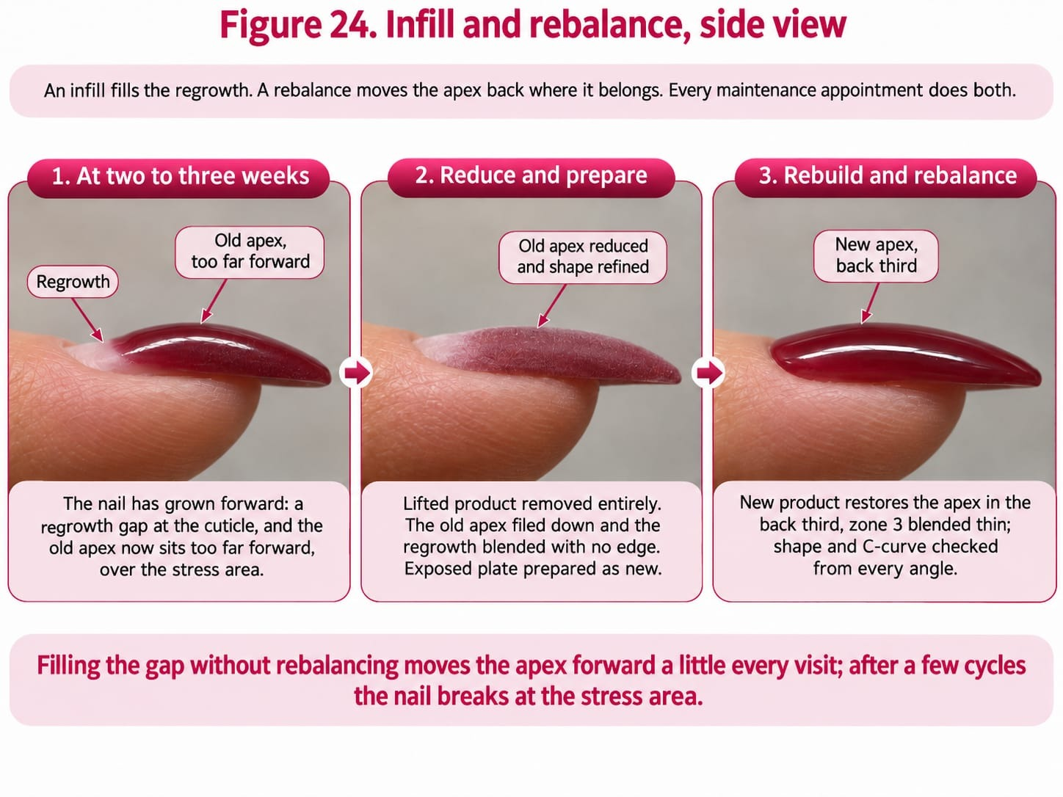

Repairs
Presentation | Action
Small surface crack, nail otherwise sound | Reduce the area, rebuild with product, rebalance.
Crack through the stress area | Remove that nail's product back to sound material and rebuild. A patched structural crack will fail again.
Lifted corner | Remove the lifted product entirely, re-prepare and rebuild. Do not fill over it.
Nail broken with damage to the natural plate | Do not rebuild over damaged tissue. Remove, assess, and refer if the plate or bed is compromised.
Green or dark discolouration beneath the product | Stop. Do not cover. Follow the green-nail procedure in Chapter 4 and refer.

Removal
Set out the full soak-off kit before you start, so the client is never left soaking while you look for something. Use either the soak pots or the foil wraps, as the system manufacturer directs.
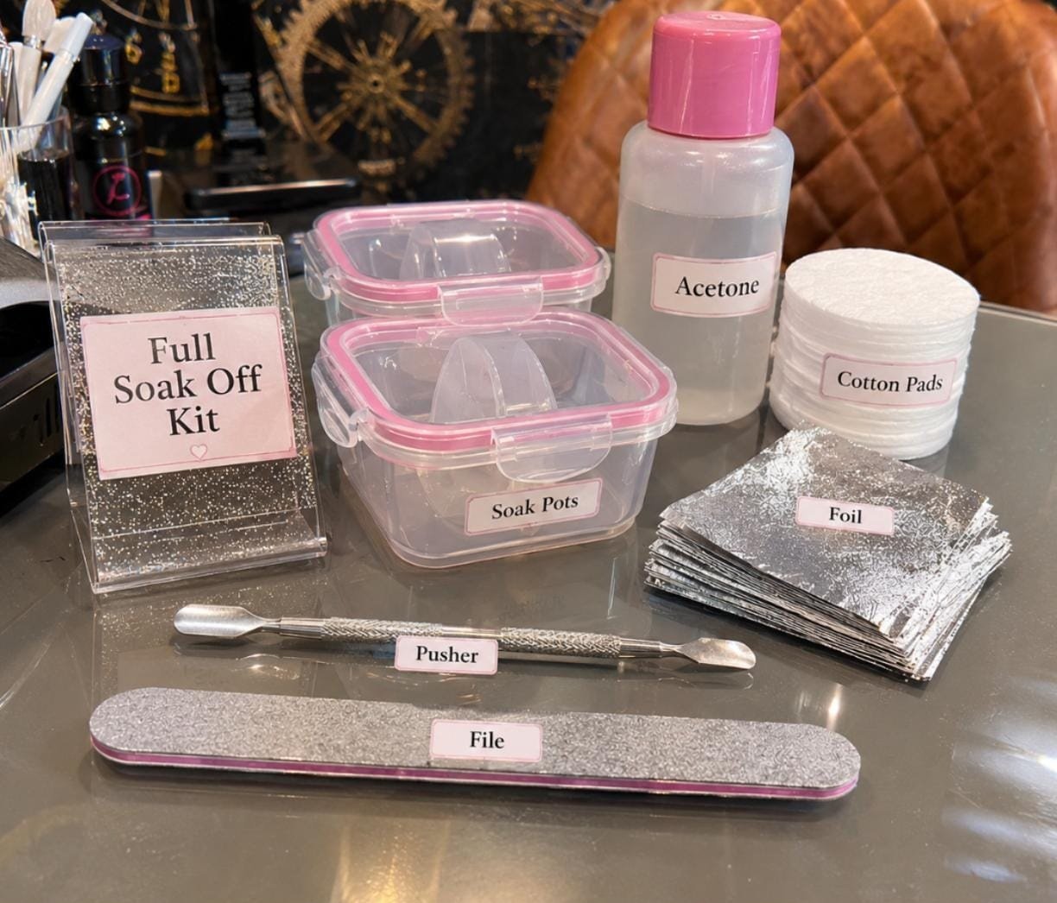
A full soak-off kit set out before removal begins: soak pots, acetone in a labelled bottle, cotton pads, foil squares for wraps, a pusher and a file.
Photograph © The Looking Glass Beauty School, 2026.
- File (100/180): reduces the bulk of the enhancement to a thin layer before soaking, so the acetone has less product to work through.
- Acetone, in a labelled and capped bottle: softens the acrylic. It is highly flammable and dries the skin, so decant only what the service needs and keep it away from heat and naked flames.
- Soak pots: hold a small amount of acetone for soaking the fingertips. Keep the lids on between uses to limit vapour.
- Cotton pads and foil: the wrap method. A piece of pad soaked in acetone is placed on the nail and wrapped in foil, which holds it in contact and slows evaporation.
- Pusher: eases away product that has already softened, held flat and used with no force. It is not a scraper or a lever.
- Explain the time removal will take and why it cannot be rushed.
- Reduce the bulk of the enhancement with a file, leaving a thin layer. Do not file down to the natural nail.
- Soak in acetone using the method the system specifies, protecting the surrounding skin.
- Allow the product to soften fully — commonly 20 to 30 minutes. Re-apply acetone rather than scraping at product that is still hard.
- Gently ease softened product away with the pusher held flat, or a wooden or plastic tool, working from the base towards the free edge with no force.
- Repeat the soak for any remaining product rather than prising it.
- Buff the plate lightly only if needed, rehydrate with oil, and advise on aftercare.
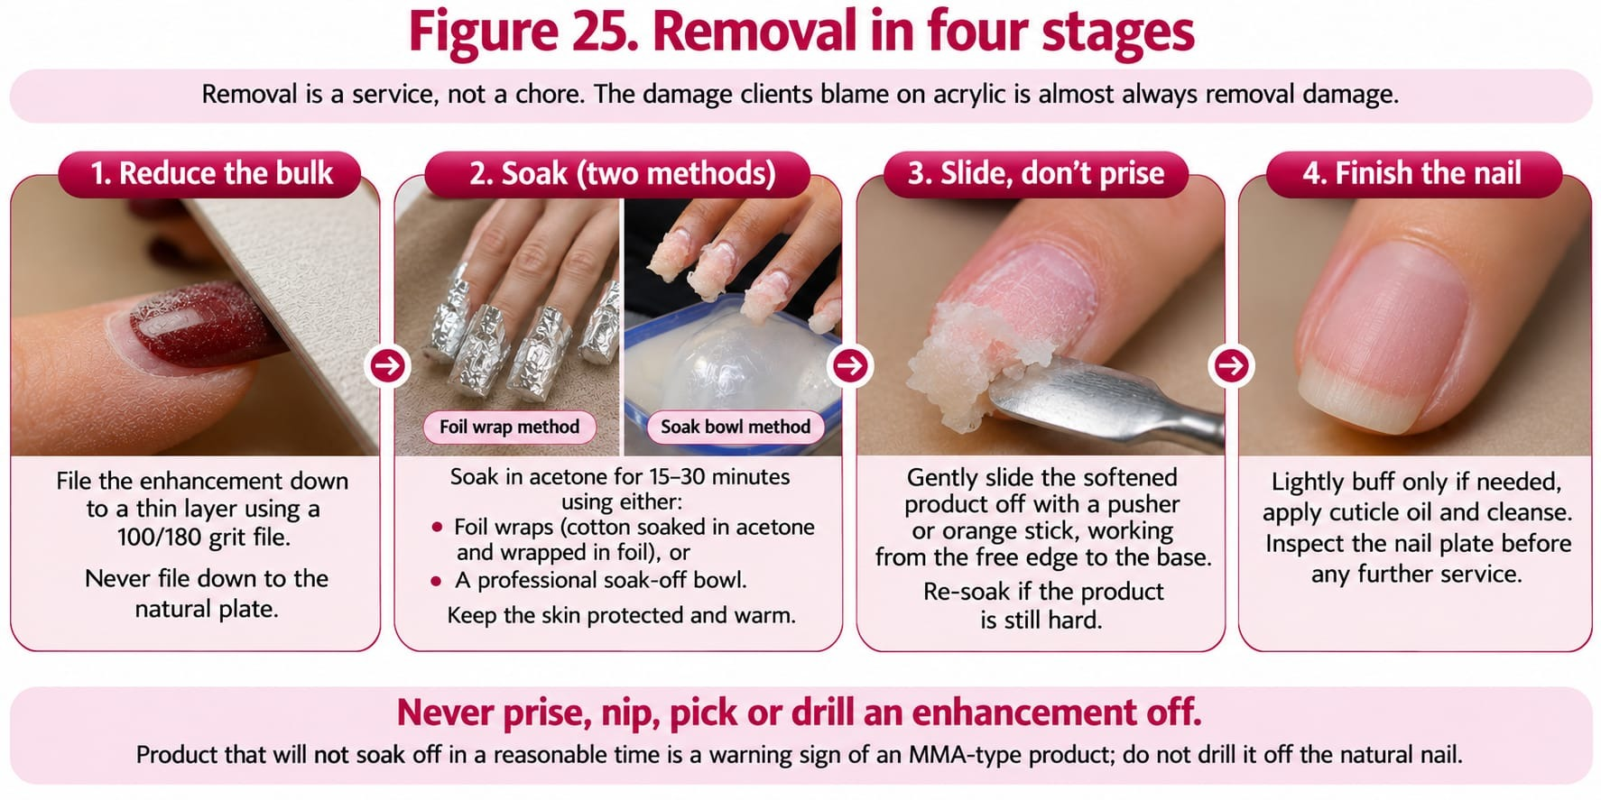
Figure 25. Removal in four stages: reduce the bulk by file, soak in acetone for 20 to 30 minutes with the skin protected, slide the softened product off with no force, then buff lightly if needed and oil. Never prise, nip, pick or drill an enhancement off.
Original photographs and artwork © The Looking Glass Beauty School, 2026.
NEVER PRISE OR NIP — Levering an enhancement off takes layers of nail plate with it. The damage clients blame on acrylic is almost always damage caused by removal.

Chapter 16 — Longevity and troubleshooting
Reading a service that has gone wrong
Problem | Likely cause | Prevention
Lifting at the cuticle area | Cuticle tissue left on the plate, product touching skin, or product applied too thickly at the margin | Thorough preparation, hairline gap, whisper-thin margin.
Lifting at the free edge or sidewalls | Poor tip fit, gap under a form, or product not sealed to the edge | Check fit before product; cap the free edge.
Cracking across the stress area | Apex too far forward, or structure too thin | Rebalance at every infill; build the apex in the back third.
Snapping at the sidewall | Sidewall filed thin to create shape | Shape with the structure, not by removing support.
Yellowing or discolouration of the product | UV exposure, smoking, some cleaning products, or old monomer | Manage client expectations; rotate stock.
Green discolouration under the product | Moisture trapped under a lifted area, associated with bacterial colonisation | Never fill over lifting. Follow the referral procedure.
Client reports itching, redness or swelling around the nails | Possible acrylate sensitisation | Stop the service, remove product safely, refer for medical assessment. Do not reapply.
Bubbles or porosity in the product | Ratio too wet, or the brush stirred air into the bead | Correct ratio; place beads, do not stir them.
Client reports heat during application | Thick application, or ratio issue | Stop, lift the hand away, apply thinner layers.

Setting expectations honestly
- Two to three weeks between infills is normal; it is not a sign that the service failed.
- Growth rate, work, hobbies and household chemicals all affect wear. So does whether the client picks.
- Enhancements do not 'make nails grow'. They protect the free edge so it is not broken off.
- The natural nail underneath is not damaged by acrylic correctly applied and correctly removed. It is damaged by over-filing and by forced removal.
- Never promise a length of wear. Explain what affects it and record what you advised.

Chapter 17 — Contra-actions, adverse reactions and emergencies
Recognise early signs, stop exposure and escalate appropriately

Contra-action or adverse reaction?
A contra-action is an unwanted response or service problem during or after treatment, such as heat discomfort, minor accidental skin abrasion, lifting or dryness. An adverse reaction is a harmful response to a product or process and may include irritant dermatitis, allergic contact dermatitis, respiratory symptoms, chemical eye exposure or burns. The professional does not diagnose the mechanism; they recognise signs, stop exposure, give proportionate first aid and refer.
Event | Possible signs | Immediate management
Warmth as product sets or during filing | Warmth or a burning feeling as a large or wet bead sets, or from heavy filing | Stop; lift the hand away; smaller beads, correct ratio, lighter filing; never tell the client to tolerate pain
Product on skin before it sets | Visible wet product, primer or monomer in the fold or on the skin | Remove at once with the brush or a clean wipe before it sets; wash the skin; do not continue until the skin is clean
Minor skin break/bleeding | Nipper/file injury | Stop; first aid and blood procedure; do not apply product; document; refer if needed
Irritant contact reaction | Burning, redness, dryness or cracking after chemical contact | Stop exposure; remove wet product; wash with soap/water; follow SDS; advise medical/pharmacy help if persistent
Suspected allergic contact dermatitis | Itching, swelling, redness, blistering, fingertip changes; may affect eyelids/face/neck | Stop all relevant nail product exposure; do not re-test; advise GP/dermatology assessment; document product/batch/SDS
Eye exposure | Stinging, watering, redness or product splash | Follow SDS immediately; irrigate with clean lukewarm water for specified time, remove contact lenses if easy, obtain urgent medical advice
Respiratory symptoms | Cough, wheeze, chest tightness, dizziness or shortness of breath | Stop work, move to fresh air if safe, follow SDS/emergency plan. Call 999 for severe breathing difficulty or collapse
Severe allergic/emergency signs | Rapid facial/throat swelling, breathing difficulty, collapse, confusion | Call 999 immediately; follow emergency/first-aid training; do not leave the person alone
Post-service lifting, cracking or breakage | Enhancement separates, cracks or breaks | Assess promptly. Remove lifted product; inspect for moisture/discolouration; repair or rebuild only when the nail is healthy
Possible infection after service | Increasing pain, heat, swelling, pus, spreading redness or green discolouration | Do not treat or cover; advise urgent pharmacy/GP/NHS 111 assessment; emergency care if systemically unwell

General adverse-reaction response
- STOP the treatment and prevent further exposure.
- REMOVE uncured/wet product safely without spreading it; do not use additional sensitising solvents on skin unless the SDS directs.
- RINSE/WASH or provide first aid according to the exact product SDS and first-aid training.
- ASSESS urgency. Call 999 for emergency signs; otherwise advise NHS 111, GP, pharmacist or occupational health as appropriate.
- RECORD factual signs, times, affected area, product names/batches, the stage of the service, PPE and extraction in use, action, advice and witnesses. Photograph only with consent and without delaying care.
- REPORT internally, to insurer and under RIDDOR/OPSS rules where applicable. Preserve product/records; do not alter notes.
- REVIEW the COSHH assessment, product system, extraction, training and technique before any further service. Do not perform a salon 'patch test' to prove safety.

Allergy prevention for professionals
- Keep uncured product off your own skin and the client's skin every time, not only when a reaction is suspected.
- Keep the dappen dish lidded, wipe the brush on the lip of the dish and never on a towel, clean bottle necks, and do not let the brush handle, your gloves or the desk become coated in product.
- Change contaminated gloves immediately and select glove material/change intervals from the SDS/COSHH assessment.
- Do not touch your face, phone, pen or door handles with contaminated gloves.
- Use source-capture extraction for every filing and removal; dust from product that has not fully set can sensitise as well as irritate.
- Report hand eczema, cracking, eyelid/facial rash, cough or wheeze early. Once sensitised, continued exposure can jeopardise a technician's career and future medical/dental choices.

Chapter 18 — Aftercare and professional client support
Clear advice protects the service and the natural nail

Aftercare advice
- Apply cuticle oil to intact skin daily and massage around, not beneath, the enhancement. Stop if irritation occurs.
- Wear suitable gloves for prolonged wet work, cleaning, gardening and chemical exposure; dry hands thoroughly afterwards.
- Do not pick, peel, bite or prise the enhancement. Do not use nails as tools to open cans, scrape labels or lift objects.
- Keep the chosen length practical. If an edge catches, contact the nail professional; do not tear it or glue a damaged natural nail without advice.
- Book an infill and rebalance every two to three weeks, and professional removal when you want to stop. Never leave a set to grow out or pull it off.
- Contact the salon promptly for lifting, a crack, trapped moisture, green/black/yellow change, unexpected white/powdery area or significant chip.
- Stop product exposure and seek advice for itching, redness, swelling, blistering, burning, fingertip changes or rash on hands/face/eyelids. Seek emergency help for breathing or throat/facial swelling.
- Do not cover a changed nail with ordinary polish or another enhancement before it has been assessed.
- Acetone removal may leave skin/nails temporarily dry; moisturise intact skin and keep nails short if not reapplying.
- Results vary: aftercare supports wear but cannot make an enhancement indestructible or guarantee a fixed number of days.

Written aftercare handout
CLIENT TAKEAWAY — LOOK AFTER YOUR ENHANCEMENTS: Oil intact cuticle skin daily. Wear gloves for wet/chemical work. Never pick or peel. Keep nails at a practical length. Book professional removal. Contact us for lifting, damage, colour change or discomfort. Stop exposure and seek medical advice for a suspected reaction; call 999 for breathing difficulty, collapse or rapid face/throat swelling.

Professional follow-up
- Record the advice given and the recommended review/removal date.
- Invite the client to report early problems without blame. Early lifting can be removed before moisture is trapped.
- At the next visit, compare wear with the previous plan and adjust length, shape, preparation or system only for a clear reason.
- Do not repeatedly repair the same failure without investigating product compatibility, equipment, technique, nail condition and lifestyle.
- Document complaints factually, preserve photographs/product records and follow the salon's complaint and insurer-notification procedure.
TEACH-BACK ACTIVITY In pairs, give the client aftercare in 60 seconds. The listener checks that you covered professional removal, wet-work protection, no picking, early reporting of lifting or colour change, and urgent reaction signs. Swap roles and improve one phrase.

Chapter 19 — Course conclusion and next steps
What you can now do, and where to go from here

What you have covered
Chapter 1 set out ten learning outcomes. By the end of the taught day, and once your three case studies are complete, you should be able to:
- say what liquid-and-powder acrylic is for, who it suits, and when gel polish, builder gel or no enhancement at all is the honest answer (LO1);
- name the structures of the nail unit and recognise the conditions that mean adapt, postpone or refuse (LO2);
- consult, record and gain informed consent, and write a treatment plan another professional could follow (LO3);
- explain monomer, polymer, initiator and catalyst, the mix ratio and set time, and the difference between EMA and MMA (LO4);
- select, handle, store and dispose of products and equipment under COSHH and the manufacturer's instructions (LO5);
- control dust and vapour at the workstation and explain why acrylate overexposure causes sensitisation (LO6);
- prepare the natural nail without damage to the plate or living tissue (LO7);
- fit and blend a tip, or fit a sculpting form, sidewall to sidewall with no gaps (LO8);
- build a balanced structure in zones with a controlled bead, a correctly placed apex, straight sidewalls and an even C-curve (LO9);
- refine, finish, infill, repair and remove an enhancement safely, and give aftercare (LO10).

Questions, feedback and reflection
Ask anything that is still unclear before you leave the taught day; a question asked now is a lifted nail avoided later. Complete the course evaluation form before you go: it is read, and the course changes because of it. The reflective practice form that goes with your case studies asks what went well, what you would change and what you need to practise; fill it in honestly, because it is for you.

Certificate, insurance and scope
- The CPD certificate is issued when the theory paper, the practical observation and all three case studies are satisfactory; attendance alone does not earn it.
- Before offering the service commercially, send your insurer the certificate and your underlying qualification and get written confirmation that liquid-and-powder enhancements are covered; check your local authority's licensing conditions, some of which prohibit MMA by name.
- Describe the training accurately: 'completed the Liquid and Powder Acrylic Enhancement CPD Course', never 'qualified' on the strength of a CPD day.

Building confidence
Start with overlays and short extensions on healthy natural nails, for clients who are not hard on their hands. Add length, sculpted forms and the demanding shapes once your beads are consistent, your apex lands in the back third without thinking about it, and your infills rebalance rather than fill. Keep a side and a barrel photograph of every set for the first three months and compare them; the improvement is quicker to see than to feel.

Further training and support
Acrylic is the strongest and most sculptable of the nail systems compared in Chapter 2. The natural next steps at The Looking Glass Beauty School are the Builder Gel Overlay and Short Extension CPD Course, for clients who want a lighter structural service, and the Gel Polish Nails CPD Course for colour over the natural nail and over enhancements; electric-file work and advanced sculpting are separate activities with their own assessment. Support continues after the course: contact the school by phone, message or email with questions about products, technique or a client you are unsure about. We would rather hear from you than have you guess. Details of every course and how to book are on the school's website and social media.
THANK YOU — for choosing The Looking Glass Beauty School. Correct ratio, hairline gap, apex in the back third, extraction on, and nothing ever prised off: the rest is practice.

Chapter 20 — Learner activities and knowledge checks
Work through these before, during and after the taught day

Before the taught day
- Read Chapters 1 to 10 and note three questions to bring with you.
- Obtain the Safety Data Sheet for the monomer and powder you will use. Write down the named monomer, the hazard statements and the storage requirements.
- Write, in your own words, what a correct bead looks like and what a wet bead does to a client.
- Sketch a side view of a nail and mark where the apex should sit.

Knowledge checks
# | Question
1 | Explain in your own words what happens chemically when monomer meets polymer powder.
2 | Give three things that change the set time of an acrylic bead.
3 | Describe a correct bead, a wet bead and a dry bead, and the consequence of each.
4 | Where does the apex belong and why does its position matter?
5 | State the accurate legal position of MMA in Great Britain, and four warning signs of an MMA-type product.
6 | Name the two exposures specific to acrylic work and one control measure for each.
7 | Why is a hairline gap at the cuticle area correct technique?
8 | Give four causes of lifting and the preparation step that prevents each.
9 | Explain the difference between an infill and a rebalance.
10 | A client's nail has green discolouration under a lifted corner. Set out exactly what you do, in order.
11 | A learner says acrylic 'ruins your natural nails'. Answer them using what you now know about preparation and removal.
12 | Why is acrylate sensitisation a greater risk to you than to your client?

Scenario activities
SCENARIO A — A regular client arrives with three nails lifted at the cuticle and one with a crack through the stress area. She has a wedding in four days. Set out your assessment, what you would do to each nail, what you would say about the crack, and what you would record.
SCENARIO B — Midway through a set you notice the beads are spreading and flooding the sidewalls, and the room is warmer than usual. Explain what is happening, what you change, and why leaving it would matter beyond appearance.
SCENARIO C — A new client asks for MMA product by name because it 'lasts longer and is cheaper'. Explain your response, the accurate legal position, and the safety reasoning.

After the taught day
- Complete three case studies as described in Chapter 1.
- For each, record the products used, the preparation carried out, the structure achieved, the aftercare given and one thing you would do differently.
- Photograph each set from above, from the side and from the barrel view, with consent, in the same light before and after.

Chapter 21 — Learner forms and client records
Templates to evidence consultation, planning, aftercare and case studies
DATA PROTECTION These forms collect personal and sometimes special-category health data. Do not ask for information that is not necessary for treatment safety.

Form A — Acrylic enhancement consultation and treatment plan
Provider data-protection details
Data controller (school/salon name) | ______________________________________________
ICO registration reference | ______________________________________________
Privacy notice location | ______________________________________________
Lawful basis and special-category condition | ______________________________________________
Retention period | ______________________________________________

Template: the school or salon completes this block before the form is used with clients.
Client/model full name | ______________________________________________
Date of birth / confirmation aged 18+ | ______________________________________________
Telephone or preferred contact | ______________________________________________
Date and time | ______________________________________________
Technician/learner | ______________________________________________

Desired result and lifestyle
Desired colour/finish/shape/length | ______________________________________________
Work and hand-use considerations | ______________________________________________
Wet work/chemicals/sport/hobbies | ______________________________________________
Previous enhancement services and typical wear | ______________________________________________
Previous removal method and any damage | ______________________________________________

Relevant health, allergy and nail questions
Relevant question | Yes/No | Necessary details
Have you ever had itching, redness, swelling, blistering, nail lifting or rash after gel, acrylic, nail glue, adhesive or dental material?
Do you currently have pain, heat, swelling, broken skin, rash, discharge or colour change around any nail?
Have you been diagnosed with a nail/skin condition that affects this treatment area? If yes, what treatment limitation has been advised?
Are you taking medication or receiving treatment that has recently changed your skin, nails, healing or sensitivity? Record only relevant details.
Do you have diabetes, impaired circulation, reduced sensation, immune suppression or another factor that requires extra care?
Is there anything else relevant to your ability to sit for the service, remain positioned or follow aftercare?

Professional nail and skin assessment
Area | Observation | Proceed/adapt/postpone/refer
Nail plates
Nail folds/cuticle
Free edges/hyponychium
Colour/attachment
Skin integrity
Other

Agreed treatment plan
System and named products | ______________________________________________
Overlay, tip or form; length and shape agreed | ______________________________________________
Preparation/adaptations | ______________________________________________
Colour/finish/shape | ______________________________________________
Removal/review date | ______________________________________________
Price | ______________________________________________
Aftercare supplied | ______________________________________________

Treatment consent: I confirm that I have answered the relevant consultation questions honestly, had the planned acrylic enhancement service, foreseeable risks, alternatives, aftercare and costs explained, and had an opportunity to ask questions. I understand that results and wear vary and that I may ask the professional to stop at any time.
Client/model signature and date | ______________________________________________
Technician/learner signature and date | ______________________________________________
Tutor signature if assessed | ______________________________________________

Data notice/condition: I have received or can access the provider's privacy notice. Where the provider relies on explicit consent to process relevant health data, that consent must be recorded separately and must meet ICO requirements.
Relevant data-processing record / explicit-consent statement if used ____________________________________________________________________

Form B — Separate photograph consent
Photograph consent is optional and separate from treatment consent. Tick each use agreed. Refusing marketing use must not affect access to treatment.
- ☐ Assessment evidence viewed by The Looking Glass Beauty School educator/quality assurer.
- ☐ Accreditation evidence viewed by the accrediting body where required.
- ☐ Anonymous learner portfolio (no face/name/identifying jewellery).
- ☐ The Looking Glass Beauty School website/social media/marketing.
- ☐ The salon's website/social media/marketing.
How long images will be retained | ______________________________________________
How consent can be withdrawn for future use | ______________________________________________
Model name | ______________________________________________
Model signature/date | ______________________________________________
Learner/educator signature/date | ______________________________________________

Form C — Treatment record
Record field | Details
Date / technician
Consultation changes
Nail condition before service
Products, colour and batch/lot where practical
Overlay, tip or form; length and shape
Preparation and service steps
Variations/contra-actions
Outcome
Aftercare and review date
Client comments
Signatures | ______________________________________________

Form D — Three-case-study log

Case study 1
Model code/name | ______________________________________________
Date | ______________________________________________
Service and goal | ______________________________________________
Nail/skin assessment | ______________________________________________
Product system (monomer, powder, primer) | ______________________________________________
Structure: overlay, tip or form; length and shape | ______________________________________________
Preparation/adaptations | ______________________________________________
Outcome and photograph filenames | ______________________________________________
Aftercare | ______________________________________________
What went well | ______________________________________________
What I would improve | ______________________________________________
Follow-up/wear result | ______________________________________________
Educator feedback | ______________________________________________
Result: Satisfactory / Further evidence required | ______________________________________________

Case study 2
Model code/name | ______________________________________________
Date | ______________________________________________
Service and goal | ______________________________________________
Nail/skin assessment | ______________________________________________
Product system (monomer, powder, primer) | ______________________________________________
Structure: overlay, tip or form; length and shape | ______________________________________________
Preparation/adaptations | ______________________________________________
Outcome and photograph filenames | ______________________________________________
Aftercare | ______________________________________________
What went well | ______________________________________________
What I would improve | ______________________________________________
Follow-up/wear result | ______________________________________________
Educator feedback | ______________________________________________
Result: Satisfactory / Further evidence required | ______________________________________________

Case study 3
Model code/name | ______________________________________________
Date | ______________________________________________
Service and goal | ______________________________________________
Nail/skin assessment | ______________________________________________
Product system (monomer, powder, primer) | ______________________________________________
Structure: overlay, tip or form; length and shape | ______________________________________________
Preparation/adaptations | ______________________________________________
Outcome and photograph filenames | ______________________________________________
Aftercare | ______________________________________________
What went well | ______________________________________________
What I would improve | ______________________________________________
Follow-up/wear result | ______________________________________________
Educator feedback | ______________________________________________
Result: Satisfactory / Further evidence required | ______________________________________________

Form E — Adverse reaction / incident record
Client/learner/staff name | ______________________________________________
Date/time/location | ______________________________________________
Treatment stage | ______________________________________________
Factual signs and symptoms | ______________________________________________
Affected nail/skin/area | ______________________________________________
Product names, batches and SDS | ______________________________________________
Stage of the service and structure (overlay, tip, form) | ______________________________________________
PPE and ventilation in use | ______________________________________________
Immediate action/first aid | ______________________________________________
Emergency service/NHS 111/GP/pharmacist advice | ______________________________________________
Witnesses | ______________________________________________
Photograph consent/file reference | ______________________________________________
Insurer/internal/RIDDOR/OPSS notification decision | ______________________________________________
Follow-up and risk-assessment review | ______________________________________________
Completed by/signature/date | ______________________________________________

Form F — Cleaning and equipment log
Date/time | Item/area | Clean/disinfect/sterilise | Product/cycle/contact time | Completed by | Fault/action

Form G — Product system record
This record is completed twice: first during training, using the system the tutor demonstrates, and again by the learner for their own kit before offering the service commercially.
Monomer (named) | Powder | Primer and dehydrator | SDS held (date) | Supplier and batch | Date checked

Form H — Learner declaration
I understand the scope of this CPD activity and will not describe it as a regulated qualification. I will work only within my underlying qualifications, competence, insurer and local requirements; use a named professional EMA system with its Safety Data Sheet; control dust and vapour; avoid skin exposure; refuse suspected infection/reaction; and maintain accurate client and product records.
Learner name | ______________________________________________
Signature | ______________________________________________
Date | ______________________________________________
Educator name/signature | ______________________________________________

Chapter 22 — References and further reading
Authoritative sources used for technical and regulatory checking
Legislation and guidance can change; the provider reviews this list at least annually and whenever a product, insurer rule, local-authority condition or official safety alert changes.
- UK Parliament — Health and Safety at Work etc. Act 1974 — 1974 — https://www.legislation.gov.uk/ukpga/1974/37
- UK Parliament — Control of Substances Hazardous to Health Regulations 2002 — 2002 — https://www.legislation.gov.uk/uksi/2002/2677
- Health and Safety Executive — COSHH Essentials sheet SR13: Nail bars and other beauty services (control approach 2, engineering control) — 2019 — https://www.hse.gov.uk/pubns/guidance/sr13.pdf
- UK Parliament — Personal Protective Equipment at Work Regulations 1992 (as amended by the Personal Protective Equipment at Work (Amendment) Regulations 2022) — 1992/2022 — https://www.legislation.gov.uk/uksi/1992/2966
- Health and Safety Executive — Personal protective equipment (PPE) at work guidance — 2022 — https://www.hse.gov.uk/ppe/
- UK Parliament — Reporting of Injuries, Diseases and Dangerous Occurrences Regulations 2013 (RIDDOR) — 2013 — https://www.legislation.gov.uk/uksi/2013/1471
- Health and Safety Executive — RIDDOR: occupational diseases — n.d. — https://www.hse.gov.uk/riddor/
- UK Parliament — Electricity at Work Regulations 1989 — 1989 — https://www.legislation.gov.uk/uksi/1989/635
- Health and Safety Executive — Portable appliance testing (PAT) FAQs — n.d. — https://www.hse.gov.uk/electricity/faq-portable-appliance-testing.htm
- UK Parliament — Waste Electrical and Electronic Equipment Regulations 2013 — 2013 — https://www.legislation.gov.uk/uksi/2013/3113
- UK Parliament — Data Protection Act 2018 (with UK GDPR) — 2018 — https://www.legislation.gov.uk/ukpga/2018/12
- Information Commissioner's Office — Special category data: guidance — n.d. — https://ico.org.uk/for-organisations/uk-gdpr-guidance-and-resources/lawful-basis/special-category-data/
- Information Commissioner's Office — How should we obtain, record and manage consent? — n.d. — https://ico.org.uk/for-organisations/uk-gdpr-guidance-and-resources/lawful-basis/consent/
- Information Commissioner's Office — Data protection fee — n.d. — https://ico.org.uk/for-organisations/data-protection-fee/
- UK Parliament — Consumer Rights Act 2015 — 2015 — https://www.legislation.gov.uk/ukpga/2015/15
- UK Parliament — Cosmetic Products Enforcement Regulations 2013 — 2013 — https://www.legislation.gov.uk/uksi/2013/1478
- UK Parliament — London Local Authorities Act 1991 (special treatment licences) — 1991 — https://www.legislation.gov.uk/ukla/1991/13
- UK Parliament — Local Government (Miscellaneous Provisions) Act 1982 — 1982 — https://www.legislation.gov.uk/ukpga/1982/30
- UK Parliament — Civic Government (Scotland) Act 1982 — 1982 — https://www.legislation.gov.uk/ukpga/1982/45
- Welsh Parliament — Public Health (Wales) Act 2017 (special procedures) — 2017 — https://www.legislation.gov.uk/anaw/2017/2
- European Commission — Commission Regulation (EU) 2020/1682 (HEMA and di-HEMA TMHDC restriction, professional use only; as retained in the GB Cosmetics Regulation) — 2020 — https://www.legislation.gov.uk/eur/2020/1682
- European Parliament and Council — Regulation (EC) No 1223/2009 on cosmetic products (applies in Northern Ireland) — 2009 — https://eur-lex.europa.eu/legal-content/EN/TXT/?uri=CELEX%3A02009R1223-20250901
- UK Government — The Cosmetic Products Regulation (EC) No 1223/2009 (Restriction of Chemical Substances) (Amendment and Transitional Provisions) Regulations 2026, SI 2026/23 — TPO inserted as entry 1745 of Annex II; regulation 2(3) in force 15 August 2026, with transitional provision to 14 February 2027 — https://www.legislation.gov.uk/uksi/2026/23/made
- UK Government — The Cosmetic Products Regulation (EC) No 1223/2009 (Restriction of Chemical Substances) (Amendment and Transitional Provisions) (No. 2) Regulations 2026, SI 2026/109 — further Annex II and Annex III amendments — https://www.legislation.gov.uk/uksi/2026/109/made
- British Beauty Council — What does the EU ban on TPO gel nail polish mean for manicurists? — 2025 — https://britishbeautycouncil.com/what-does-the-eu-ban-on-tpo-gel-nail-polish-mean-for-manicurists/
- British Association of Dermatologists — Dermatologists issue warning about UK artificial nail allergy epidemic — 2018 — https://www.bad.org.uk/dermatologists-issue-warning-about-uk-artificial-nail-allergy-epidemic
- British Society for Cutaneous Allergy — Acrylate allergy patient information — n.d. — https://www.cutaneousallergy.org/
- NHS — Nail problems — n.d. — https://www.nhs.uk/conditions/nail-problems/
- NHS — Fungal nail infection — n.d. — https://www.nhs.uk/conditions/fungal-nail-infection/
- Advertising Standards Authority / Committee of Advertising Practice — Beauty and cosmetics: general advice online — n.d. — https://www.asa.org.uk/advice-online/beauty-and-cosmetics-general.html
- Cosmetic, Toiletry and Perfumery Association — Guidance on nail products — n.d. — https://www.ctpa.org.uk/
- Skills England (formerly Institute for Apprenticeships and Technical Education) — Nail services technician occupational standard — n.d. — https://www.instituteforapprenticeships.org/apprenticeship-standards/nail-services-technician/
- Braintree District Council — Update for Nail Technicians: Methyl Methacrylate (MMA) Monomer — 2012 — https://www.braintree.gov.uk/downloads/file/1063/updatefornailtechsmma
- Dundee City Council — Public entertainment licence: nail bar conditions (the licence holder shall not use MMA liquid monomer) — n.d. — https://www.dundeecity.gov.uk/sites/default/files/public_entertainment_-_nail_bar_conditions.docx
- European Chemicals Agency — Committee for Risk Assessment opinion on the harmonised classification of methyl methacrylate (adopted 18 March 2021: respiratory sensitiser category 1 proposed in addition to the existing skin sensitiser classification) — 2021 — https://echa.europa.eu/registry-of-clh-intentions-until-outcome
- Health and Safety Executive — Research Report RR627: Health and safety in nail bars — 2008 — https://www.hse.gov.uk/research/rrhtm/rr627.htm
- American Academy of Dermatology — Artificial nails: dermatologists' tips for reducing nail damage — n.d. — https://www.aad.org/nail-care-secrets/reduce-artificial-nail-damage
All references checked 27 October 2026 as part of the scheduled document review.

